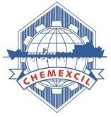

ANNEXURE - I

BRIEF REPORT

INDIA PAVILION AT KHIMIA 2023

30th October – 2nd November, 2023

Moscow, Russia

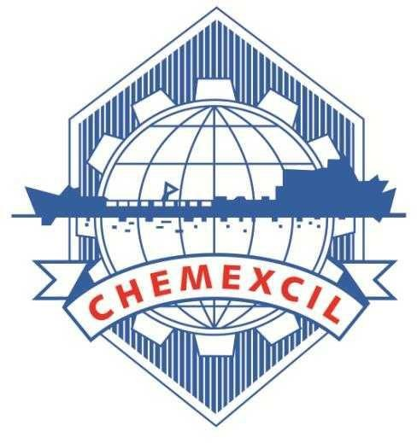

CHEMEXCIL

Basic Chemicals, Cosmetics & Dyes Export Promotion Council
(Set-up by Ministry of Commerce & Industry, Government of India) Jhansi Castle, 4th Floor, 7- Cooperage Road, Mumbai – 400 001, INDIA
Tel: +91-22-22021288, 22021330, 22825861, 22020911, Fax: +91-22-22026684
Email: info@chemexcil.in Website: https://chemexcil.in Twitter: @chemexcil

HIGHLIGHTS

As an export promotion activity for the year 2023-2024 Chemexcil organized India Pavilion at KHIMIA 2023 exhibition during 30th October – 2nd November, 2023 at Expocentre Fairgrounds, Moscow, Russia. This event was recommended to DOC under the MAI Scheme of the Department of Commerce, Government of India.

The Ministry of Commerce & Industry has recommended the said project under the MAI scheme vide letter no. F. NO. K-11020/182/2022-E&MDA dated 14th March, 2023 (Minutes of Meetings of Sub- Committee of MAI to consider proposals for MAI assistance for the activities to be undertaken by EPC’s/ Trade Bodies during the FY 2023-24) for 20-exhibitors.

Khimia international exhibition was launched in 1965 and is considered to be the most prestigious event for chemical industry in Russia. The event brings together all sectors of chemical industry such as chemical manufacturers, service providers, suppliers of the latest equipment, materials , technologies, and consumers from different nations. The focus areas of the exhibition included industry patrons from Chemical and petrochemicals , Agro chemicals, Oil and gas , Pharmaceutical, medicine, Textile etc.

Russia is an important market especially for Inorganics, Organics & Agro Chemicals, Dyes & Dye Intermediates and Cosmetics sector. The main objectives to organize Indian Pavilion Meet were:-

- Promotion of Indian Chemical exports in Russia.
- Establishment of networking opportunities for mutual cooperation in the Chemical sector.
- Focused B2B meetings with stakeholders of local chemical industry.
- Exploring the possibility of expanding two-way trade.

The 26th edition of KHIMIA international exhibition was a perfect platform for Indian companies to interact and connect with the Russian chemical industry and explore opportunities of trade as the market is currently looking for potential and reliable suppliers amid current crisis due to sanctions from European nations.

The Inauguration Ceremony was organized on 30th October, 2023 at 1200 hrs. (Russian Time). The Indian Pavilion was inaugurated by :

- Smt. Gina Uika, Deputy Chief of Mission – Embassy of India in Moscow
- Shri. Rajnish Patidar, Second Secretary - Embassy of India in Moscow and,
- Mr. Kumar Siddhartha, Regional Director – Chemexcil.

Later, Smt. Gina Uika visited the Indian Pavilion and met with participants at their respective stalls. The members-exporters were happy to interact with the visiting dignitaries.

In total 20 member-exporters from CHEMEXCIL participated in this Exhibition with total area of 120 sqmtr. The 4 day exhibition witnessed over 11000 visitors from 13 nations exploring 19200 sqm of exhibition area showcased by 498 exhibitors from around the world.

Participants in the show had the opportunity to attend various knowledge programs wherein 30+ events were organized comprising of 270+ speakers and 4500+ Business delegates during the exhibition days. Moreover a specific India Day Session was organized on 1st November, 2023 to highlight the strengths of Indian chemical industry and enhance the engagements between the stakeholders of Indian and Russian chemical industry. The key highlights are as below :

- Mr. Victor Ivanov , President – Russian Chemists Union initiated his welcome remarks and acknowledged the participation of Indian pavilion for the first time, with many companies representing various sectors of the chemical industry. Russian business is showing great interest in them and many contacts will be made between Indian and Russian businessmen during this exhibition.

- Kumar Siddhartha, Regional Director - CHEMEXCIL gave a brief overview of the Indian chemical industry and praised the economic cooperation between the nations, particularly in the field of chemical industry.

- Andrey Paevsky, Head of the Agency for Attracting Investments in the Ivanovo Region and Alexander Suslov, Project Manager at the Development Centre of the Indian branch of Sberbank, spoke in detail about the investment opportunities between India-Russia cooperation.

In addition to the exhibition, Embassy of India in Moscow, Russia in association with Russian Chemists Union organized a separate B2B meeting followed by dinner on 2nd November, 2023. This event was attended by the representatives of the Russian Ministry of Industry and Trade, Russian-Asian Business Council, Business Russia, Russian banks, logistics companies, and Russian companies in the chemical sector. More than 50 Business delegates from Russia participated and met the Indian delegation with an objective to explore mutually beneficial trade opportunities in the chemical sector.

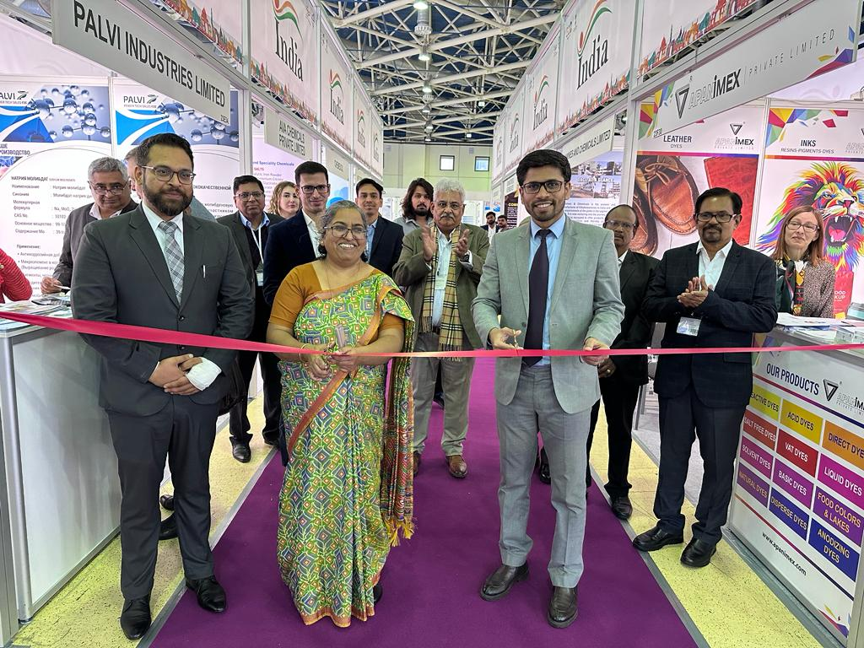

Smt. Gina Uika, Deputy Chief of Mission & Mr. Rajnish Patidar, Deputy Head (Economic & Commerce Wing), Embassy of India in Moscow, Russia inaugurating the Indian Pavilion.
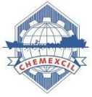

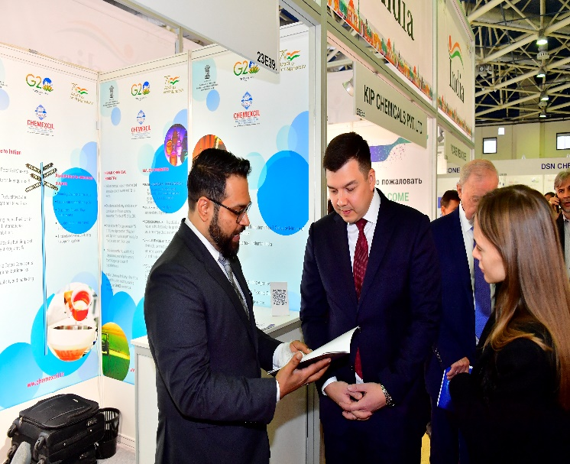

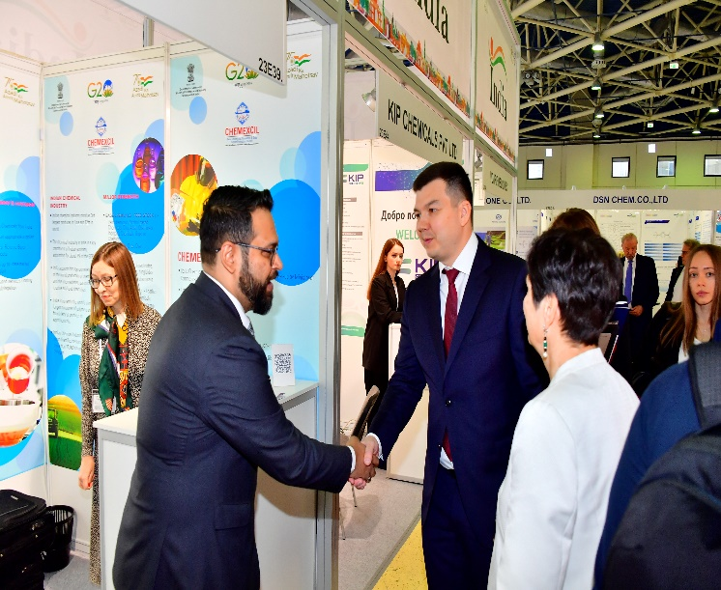

H.E. Mr. Mikhail Yurin - Deputy Minister of Industry and Trade of Russia visited India Pavilion after the official inaugural ceremony of KHIMIA 2023 on 30th October, 2023. Mr. Kumar Siddhartha – Regional Director, Chemexcil briefed him about Chemexcil and its endeavors towards enhancement of trade relationship between INDIA & RUSSIA.

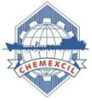

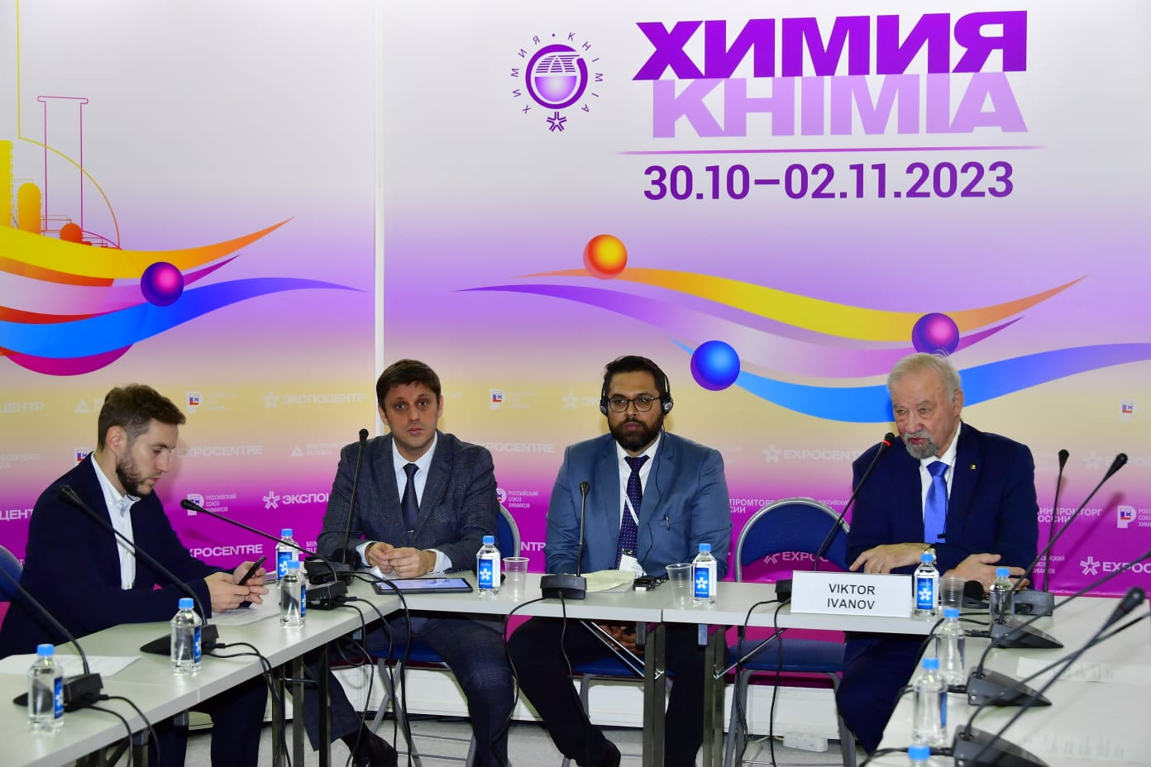

INDIA DAY session on 1st November, 2023

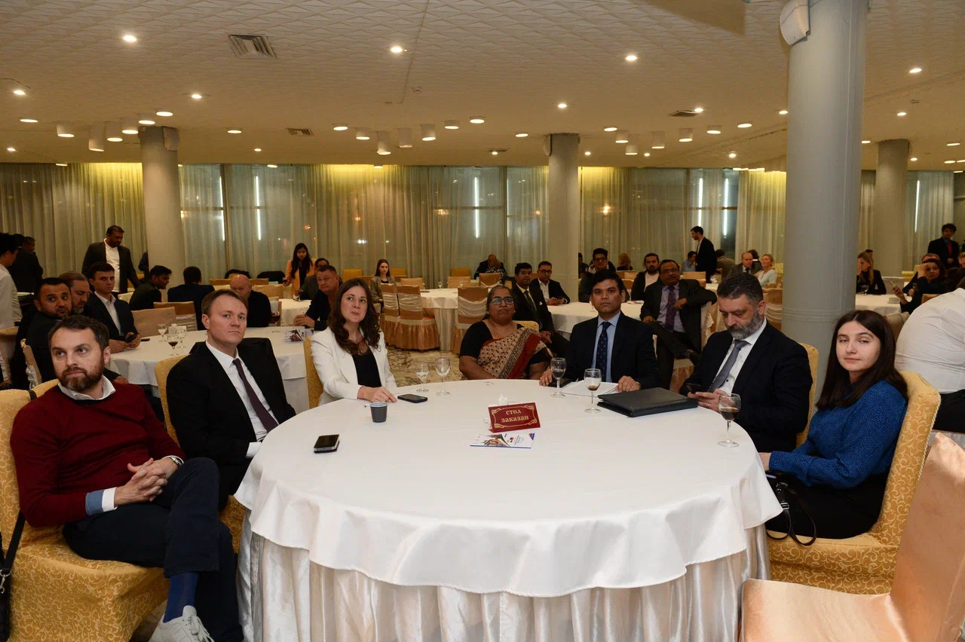
Smt. Gina Uika, Deputy Chief of Mission along with representatives of the Russian Ministry of Industry and Trade, Russian-Asian Business Council, Business Russia during B2B meetings organized on 2nd November, 2023

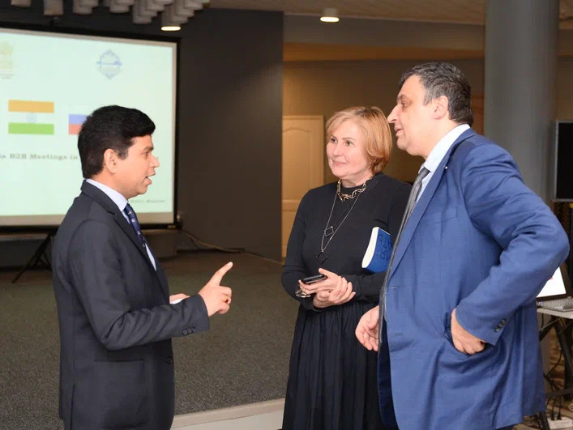

Shri Ved Prakash Singh, First Secretary – Embassy of India in Moscow, Russia interacting with stakeholders of Russian Chemical Industry during B2B meet on 2nd November, 2023

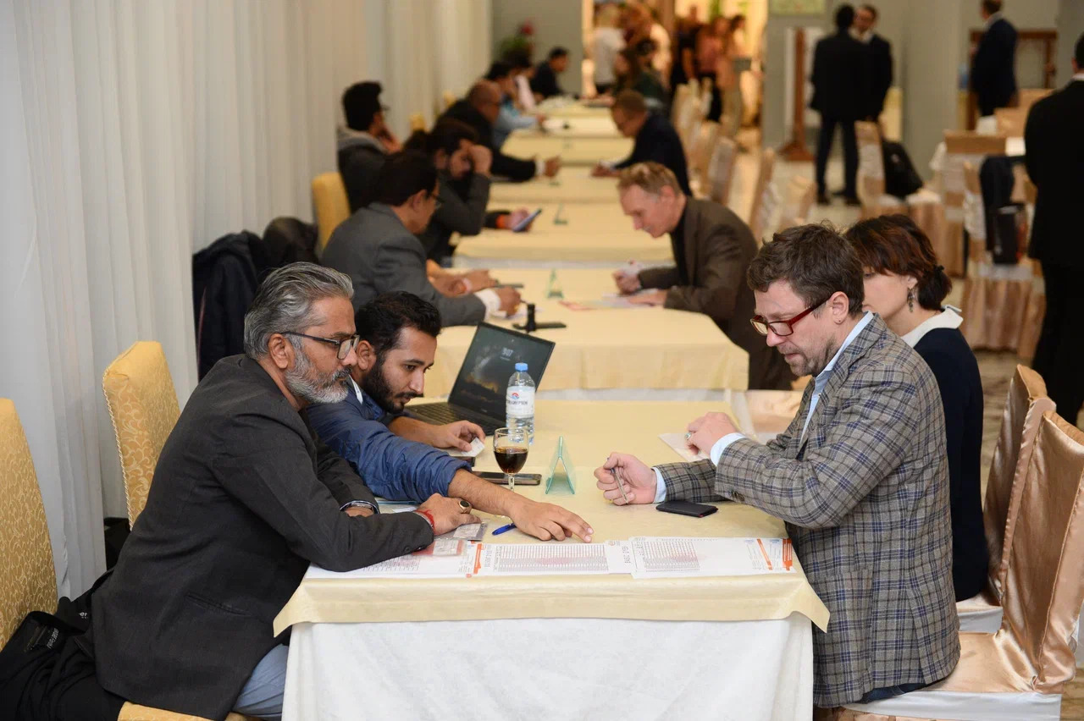
B2B Meetings on 2nd November, 2023
GLIMPSES OF INDIAN PAVILION

