BRIEF REPORT ON
CHEMEXCIL’S PARTICIPATION IN

38th Dye+Chem Bangladesh Expo’2019

FROM

4th to 7th September, 2019
AT
International Convention City, Bashundhara, Dhaka, BANGLADESH

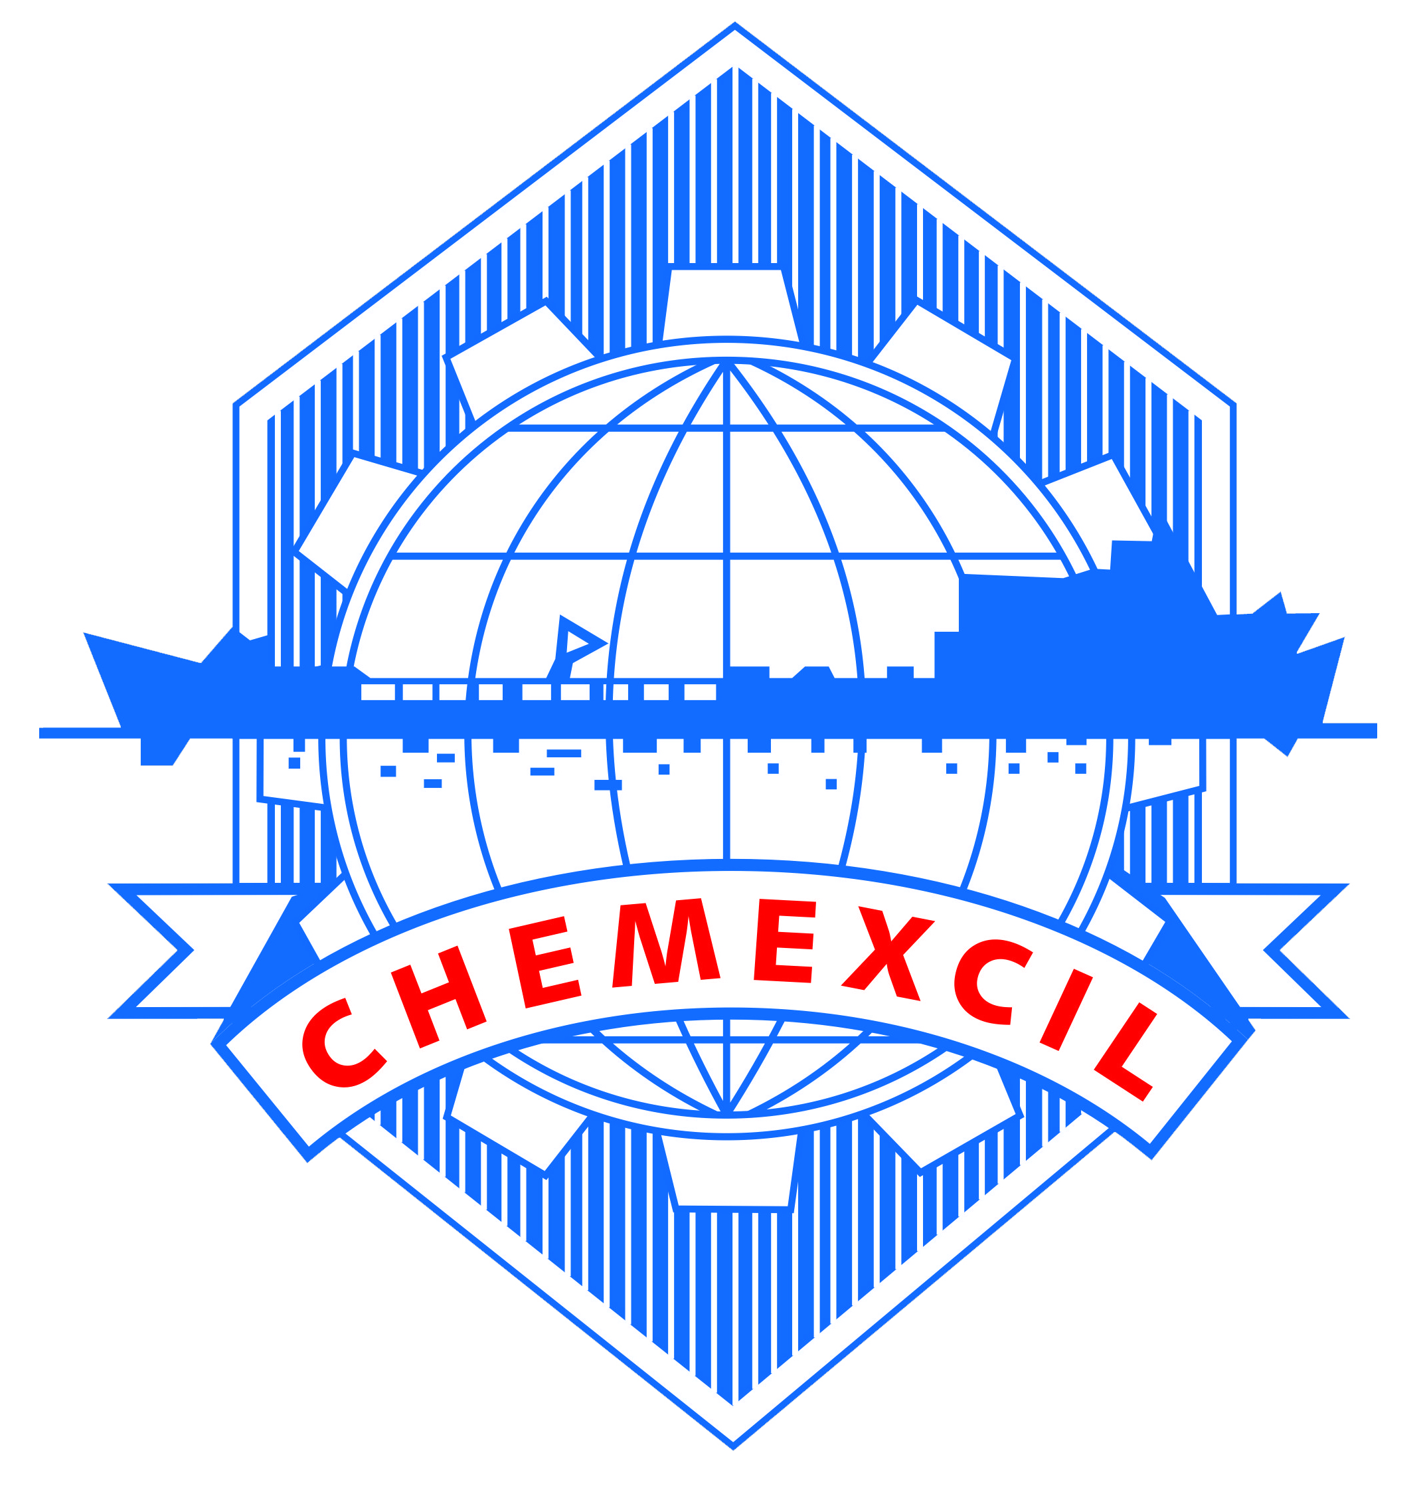
CHEMEXCIL
Basic Chemicals, Cosmetics & Dyes Export Promotion Council
(Set-up by Ministry of Commerce & Industry, Government of India)
Jhansi Castle, 4th Floor, 7- Cooperage Road, Mumbai – 400 001, INDIA
Tel: +91-22-22021288, 22021330, 22825861, 22020911, Fax: +91-22-22026684
Email: info@chemexcil.gov.in
Website: https://chemexcil.in

HIGHLIGHTS - 38th Dye+Chem Bangladesh Exhibition 2019

As an export promotion measure, CHEMEXCIL has participated in 38th Dye+Chem Bangladesh Exhibition’ 2019 organized by the by “CEMS-Global USA’ and “CEMS Bangladesh” from 4th September to 7th September, 2019 at the International Convention City, Bashundhara, Dhaka, Bangladesh. It was concurrently held with 20th Textech Bangladesh 2019 International Expo and 16th Dhaka International Yarn & Fabric Show 2019.

Dye+Chem Bangladesh exhibition is an exclusive and most prestigious International Exhibition in Bangladesh devoted to focus on all kinds of Dyes and Fine & Specialty Chemicals for the Bangladesh Industry and specially USD 32 Bn Ready Made Garments (RMG) sector. This exhibition is the gateway to the Dyes and Fine & Specialty Chemicals sector of Bangladesh and a perfect B2B platform for overseas manufacturers of Dyes & Dyes Intermediate, Basic chemicals to showcase their products under one roof. This expo has provided an interactive platform for Exhibitors to generate business through displays / direct interaction with the Buyers.

The exhibition venue was spread over 80,000m² for all the three concurrent shows, evincing participation of reputed producers from around the world. There were total 1250 exhibitors from domestic industry and other countries such as India, China, Turkey, Spain, Indonesia, Sri Lanka, Japan, Italy, Taiwan, Pakistan, Russia, South Korea, France, USA, Germany, Philippines, and Myanmar etc. The exhibits scope varied from textile chemicals such as dyestuffs, pigments, intermediates to textile machinery, fibres, yarns, color card, etc. The exhibition was attended by over 10,000 visitors.

Bangladesh majorly imports dyes & textile chemicals from countries like India, Singapore, China, Taiwan and South Korea etc. The demand for dyes & textile chemicals in Bangladesh is largely driven by exports of knitted and woven garments from the country to international market. The main objectives to participate in this Trade fair were:-

• To establish good contacts with business enterprises and commercial organizations and to build the vibrant platform for promoting exports to Bangladesh.

• To explore the possibilities of expansion of two way trade.

• Possibilities of collaboration in Bangladesh.

The Council had booked an area of 150 sq mt for organising its India Pavilion at Level 2, Hall 5 of International Convention City Bashundra (ICCB), Dhaka wherein 25 Indian exporters had showcased their products. Council had also done special branding in and around the venue to promote brand India.

CHEMEXCIL’s Indian pavilion was inaugurated by Dr. Pramyesh Basall, Second Secretary (Commerce) / Commercial Representative, High Commission of India to Bangladesh along with Mr. Deepak Gupta, Deputy Director- Chemexcil and Mr. Soumen Guha-Regional Officer, Ro Kolkata, Chemexcil. The members-exporters were happy to interact with the visiting dignitaries.

Dye+Chem Bangladesh Exhibition’ 2019 exhibition evinced good response with around 200 visitors to Chemexcil’s India pavilion for their sourcing requirements and networking with Indian exhibitors.
Glimpses of the Exhibition

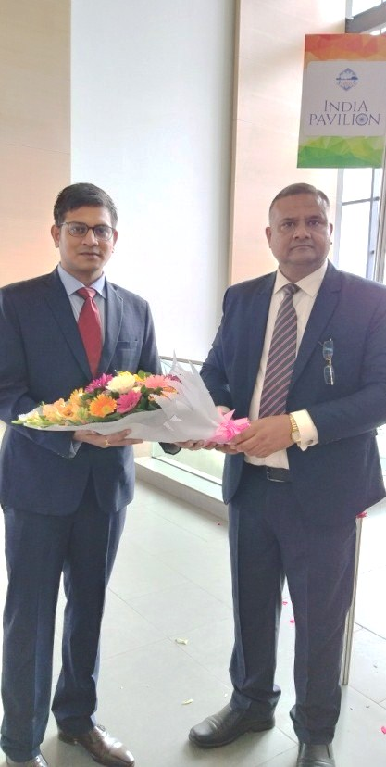
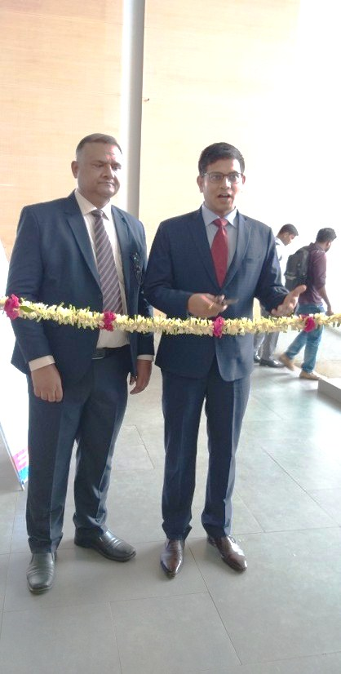

38th Dye+Chem
Bangladesh Exhibition 2019

Dr. Pramyesh Basall, Second Secretary (Commerce) / Commercial Representative, High Commission of India, Dhaka, Bangladesh being welcomed by Mr. Mr. Deepak Gupta, Dy. Director - CHEMEXCIL during inauguration of India Pavlian at 38th Dye+Chem Bangladesh Exhibition 2019

Dr. Pramyesh Basall, Second Secretary (Commerce) / Commercial Representative, High Commission of India, Dhaka, Bangladesh inaugurated Chemexcil’s India Pavilion at 38th Dye+Chem Bangladesh Exhibition 2019

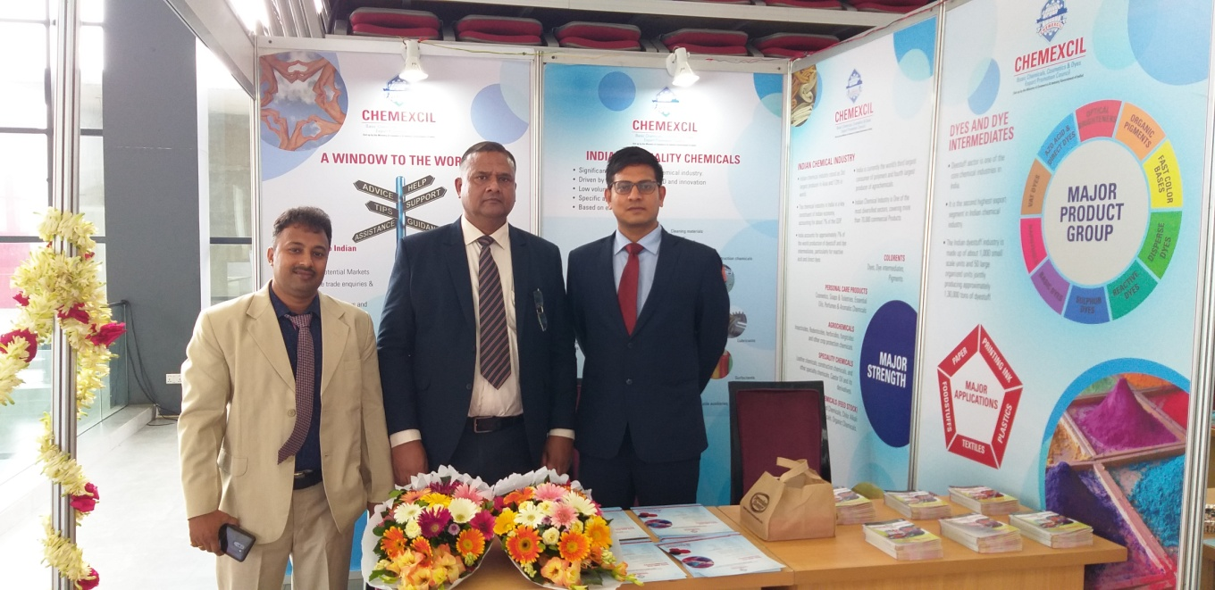
Dr. Pramyesh Basall, Second Secretary (Commerce) / Commercial Representative, High Commission of India, Dhaka, Bangladesh, Mr. Deepak Gupta, Deputy Director and Mr. Soumen Guha, Regional Officer at Council’s Stall during 38th Dye+Chem Bangladesh Exhibition 2019

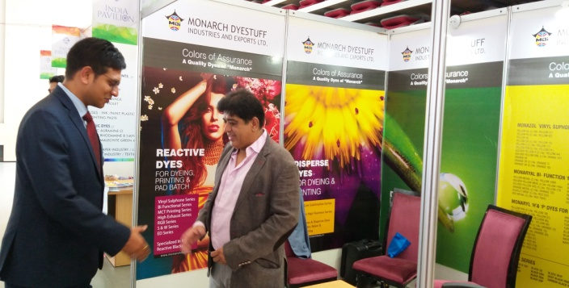 | 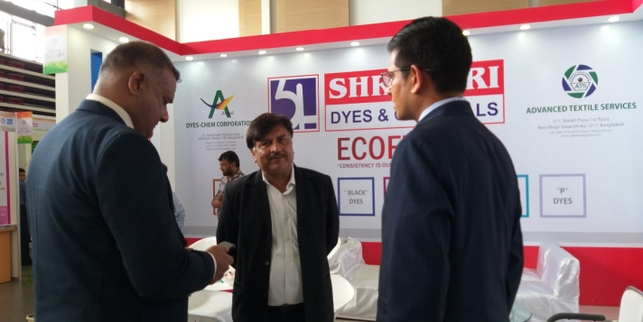
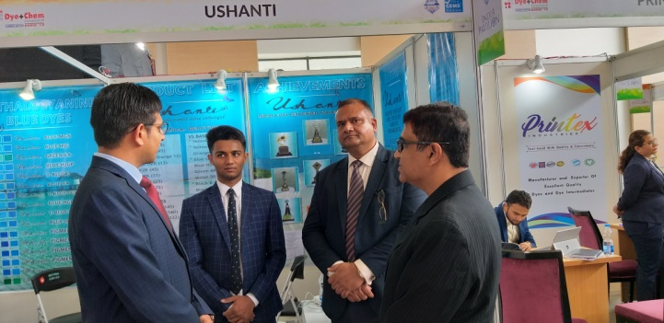 | 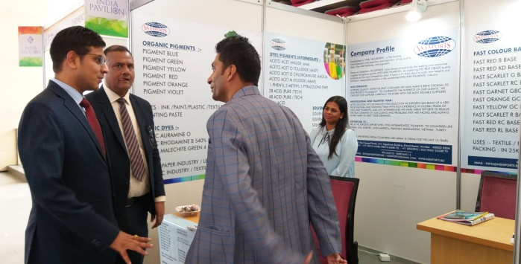
Booth Visit of Dignitaries
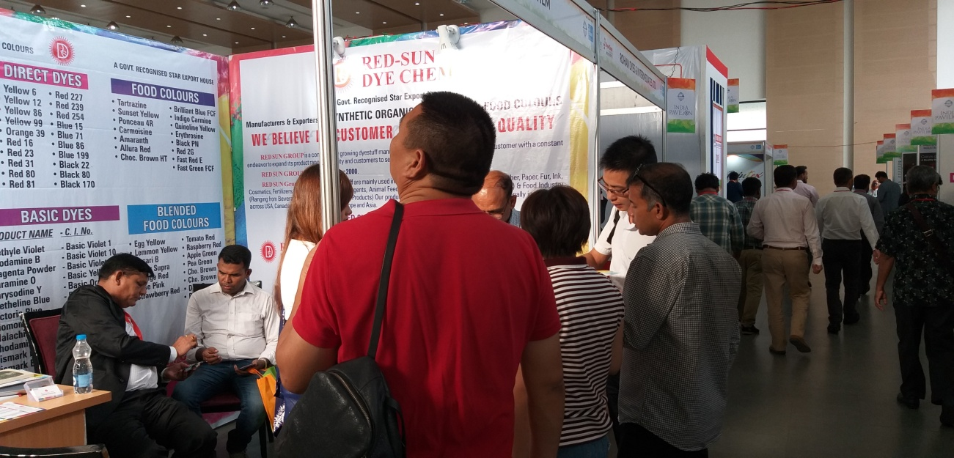

Visitors in India Pavilion during 38th Dye+Chem Bangladesh Exhibition 2019

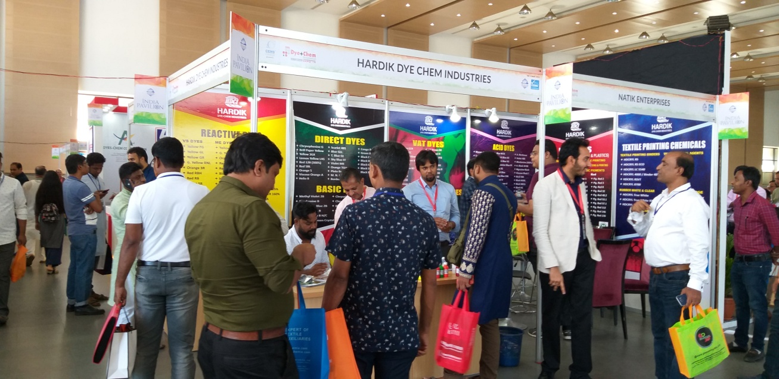

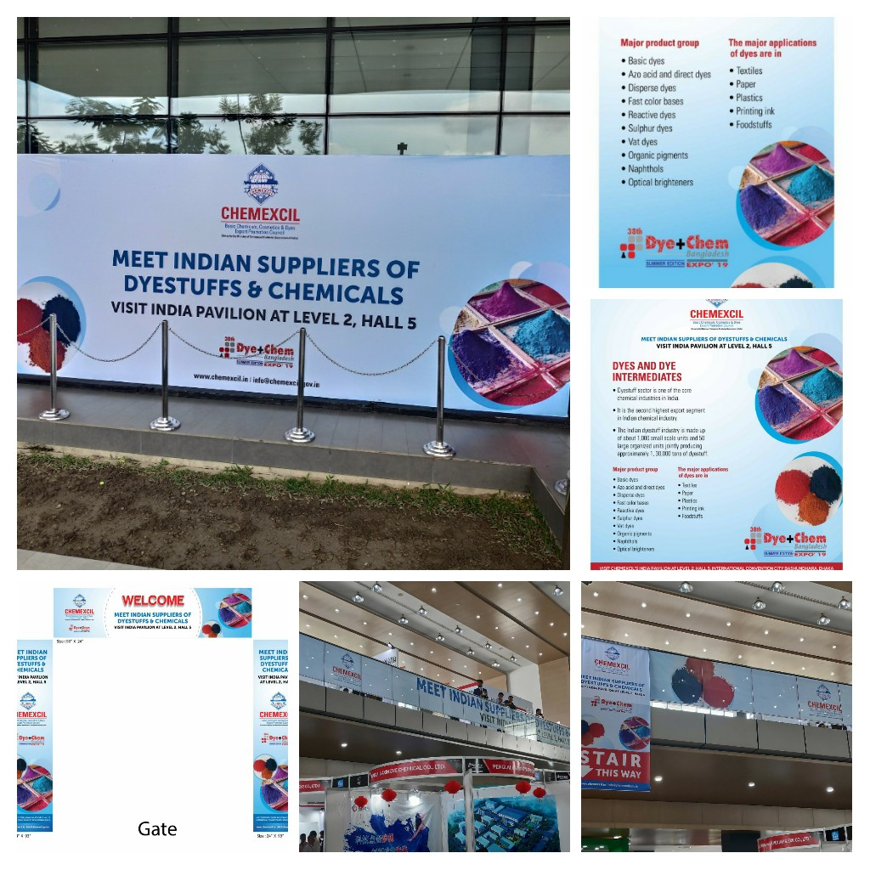

Special Branding done by Chemexcil for Dyechem 2019

