BRIEF REPORT ON INDIAN CHEMICALS & COSMETICS EXHIBITION
HELD IN DHAKA, BANGLADESH ON 8-9TH OCTOBER, 2017 AT INTERNATIONAL CONVENTION CITY BASHUNDHARA EXHIBITION CENTRE (ICCB)

ORGANISORS AND EXHIBITORS

CHAIRMAN – MR. SATISH WAGH
EXECUTIVE DIRECTOR – MR. S.G. BHARADI
REGIONAL DIRECTOR – MRS. VAISHALI ZINZUWADIA
32 COMPANIES EXHIBITED + 217 VISITORS IN TWO DAYS

Chief Guest

SECOND SECRETARY, COMMERCE – MR. SHIRISH KOTHARI, HIGH COMMISSION OF INDIA

BRIEF REPORT

The exhibition was inaugurated by Mr. Shishir Kothari, Second Secretary, Commerce from the High
Commission of India in Bangladesh.

The two days exhibition in Dhaka, Bangladesh was a successful event wherein the Indian manufacturers were able to showcase their capability as a supplier of steady and sustainable, low cost international quality products to Bangladesh. This exhibition turned out to be a platform for meeting potential buyers, dealers and end users of Chemicals, Agrochemicals, Cosmetics and Dyes in Bangladesh.

Bangladesh is Indian’s largest trade partner amongst the SAARC countries. It is also one of the biggest destinations of Indian exports in the SAARC region. India became the 11th largest destination for exports from Bangladesh in 2015-16. The total trade between the two countries has increased to US $ 6.14 billion in 2015-16 from US $ 5.2 billion in 2011-12.

Mr. Shishir Kothari laid the stress on organising such exhibitions every year to gain the momentum and showcase the strength to Indian industries to Bangladesh market. He also mentioned that for any trade dispute the High Commission office can assist Indian Companies / Individuals in amiable resolving their trade disputes with the Bangladeshi companies.

Participants from both the countries were highly satisfied, particularly with the extensive variety of products, services and know-how that were presented at the show. The exhibition survey revealed that maximum visitors were interested in setting up dealer networks and work through the agents to avoid payment issues. All exhibiting companies were satisfied with the good number of visitors and were able to develop new contacts for their business in Bangladesh.

PHOTOGRAPHS:
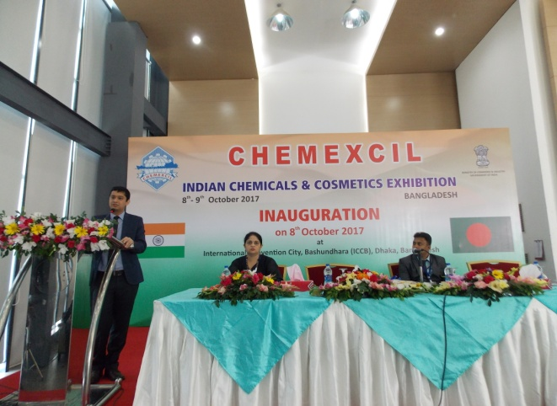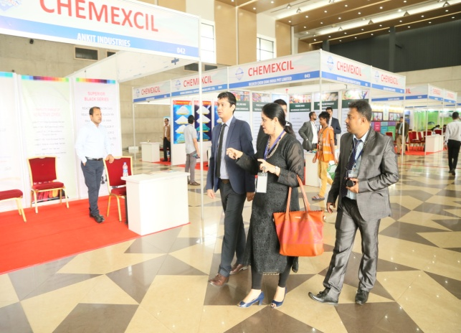
Mr. Shishir Kothari, Second Secretary (Commerce) Booth visit by Mr. Shishir Kothari, Second
High Commission of India, Dhaka –Bangladesh Secretary (Commerce), High Commission of delivering Key Note Address India, Dhaka- Bangladesh

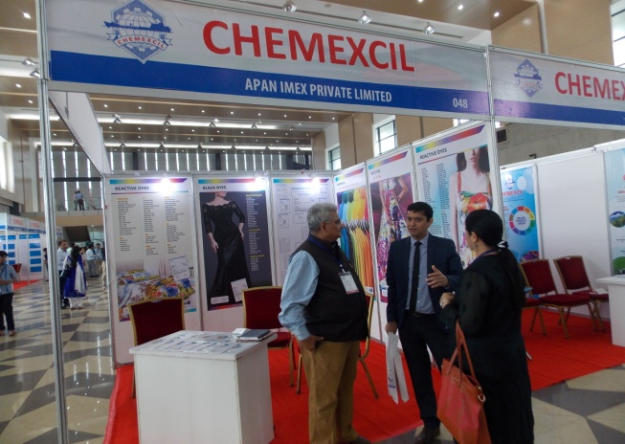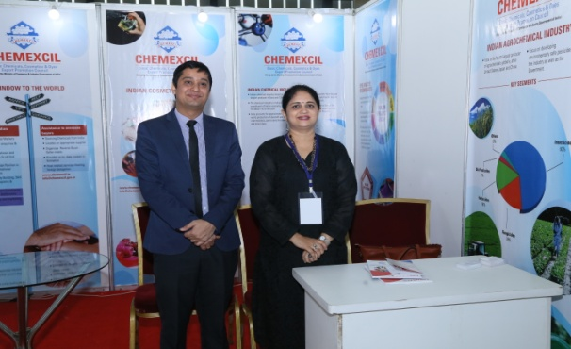
Booth visit Mr. Shishir Kothari, Second Secretary (Commerce), High Commission of India Dhaka -Bangladesh and Mrs Vaishali Zinzuwadia Regional Director CHEMEXCIL at Council’s Stall

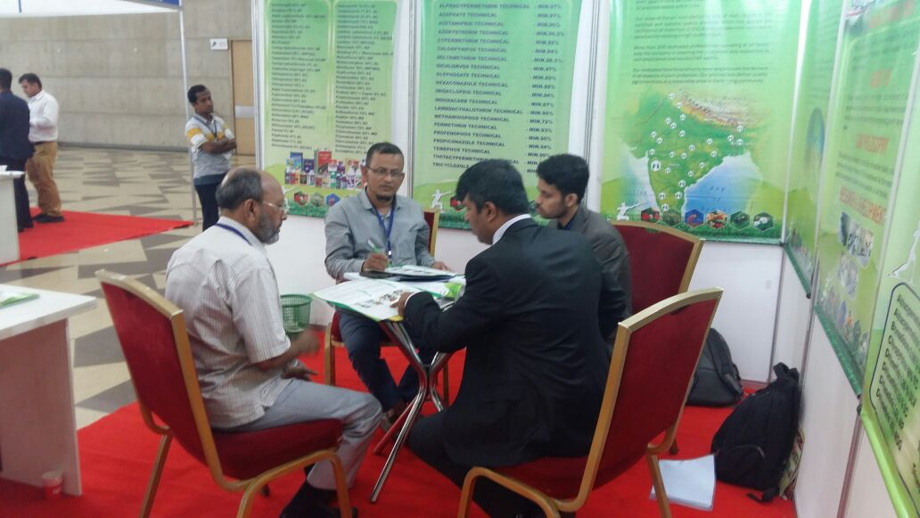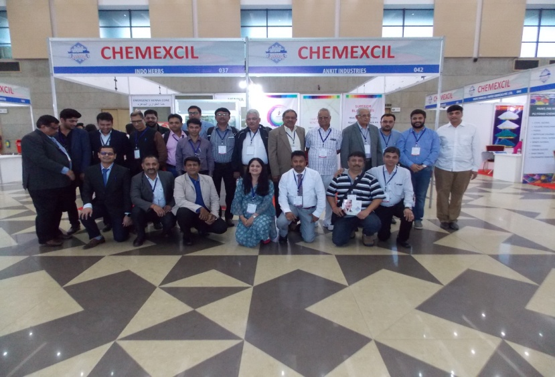
Buyer Seller Meet during Exhibition Exhibitors with Chemexcil Officials

