CHEMEXCIL
REGIONAL OFFICE
NEW DELHI
---------------------------------------------------------------------------------------------------------------------

BRIEF REPORT

ASEAN – INDIA Investment Meet & Expo
22nd – 23rd January, 2018, New Delhi

Council participated in ‘ASEAN – INDIA Investment Meet & Expo’ organized by The Ministry of Commerce & Industry in collaboration with the Ministry of External Affairs (MEA) and Confederation of Indian Industry (CII) from 22nd -23rd January, 2018 at The Ashok Hotel, New Delhi.

In the Expo there were nearly 30 Foreign Exhibitors and 38 Indian Exhibitors including EPCs, Associations & Govt. bodies to display their products and showcase their strength / capabilities in specific Sectors. The categories of the visitors at the expo included CEOs, Decision Makers, Experts, Diplomats, Trade & Government Delegation and Media.

There were two stalls pertaining to CHEMEXCIL in which four of our members relating to Cosmetics, Agro -chemicals and Dyes displayed their products to showcase their strength for creating Make in India image.

This Investment Meet & Expo was positioned as a Large Scale Conference and Exhibition to showcase the best initiatives from the government and industry across various sectors of mutual cooperation. Trade Ministers, Senior government officials and global industry experts from ASEAN member countries participated in this event. The event was inaugurated by Hon'ble Minister of Commerce & Industry and Trade Ministers from ASEAN Countries. There were plenary sessions during the summit relating to Trade & Investment, Regional Value Chains etc.

Films pertaining to CHEMEXCIL, CAPINDIA & Hon'ble CIM Message were continuously displayed during the event and visitors were informed about the services being provided by the Council for the benefit of the exporters. Council displayed Bulletins and distributed Brochures of CAPINDIA 2018 to the Visitors with briefing about this mega event.

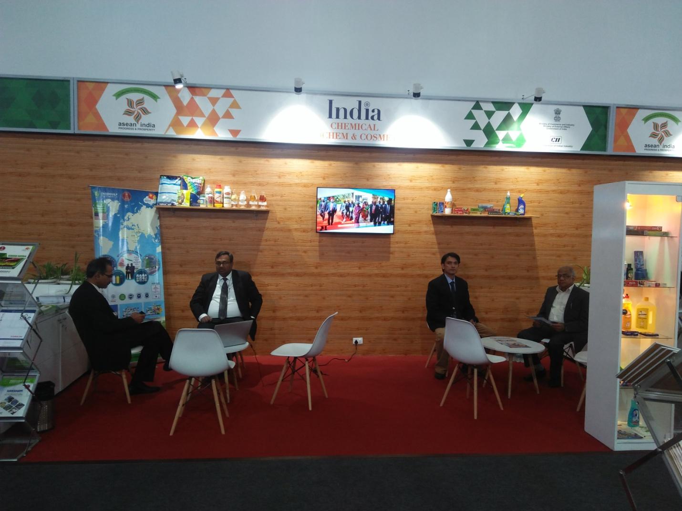

‘ASEAN – INDIA Investment Meet & Expo’ held on 22nd -23rd January, 2018 at The Ashok Hotel, New Delhi

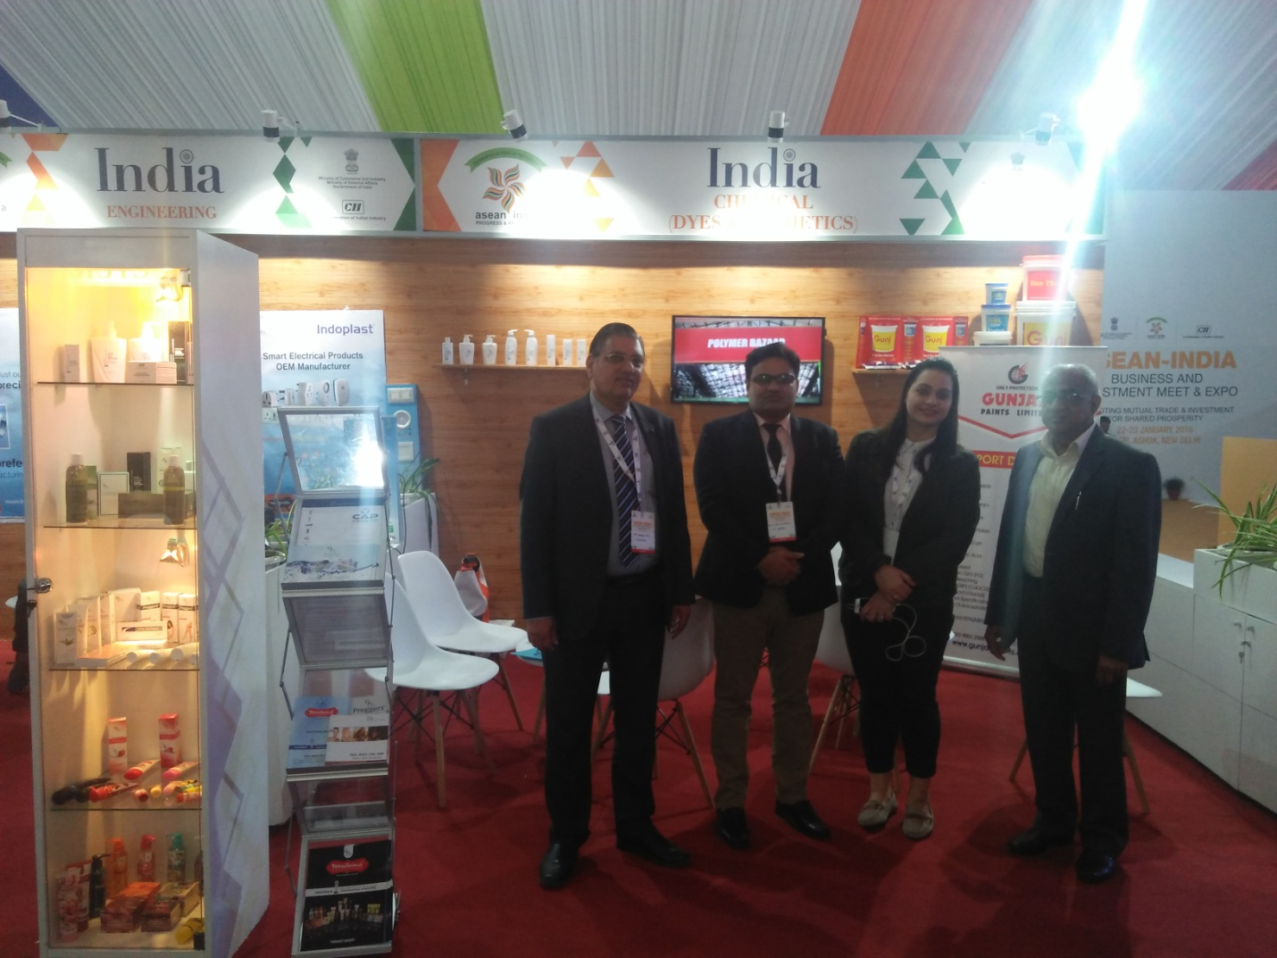

‘ASEAN – INDIA Investment Meet & Expo’ held on 22nd -23rd January, 2018 at The Ashok Hotel, New Delhi

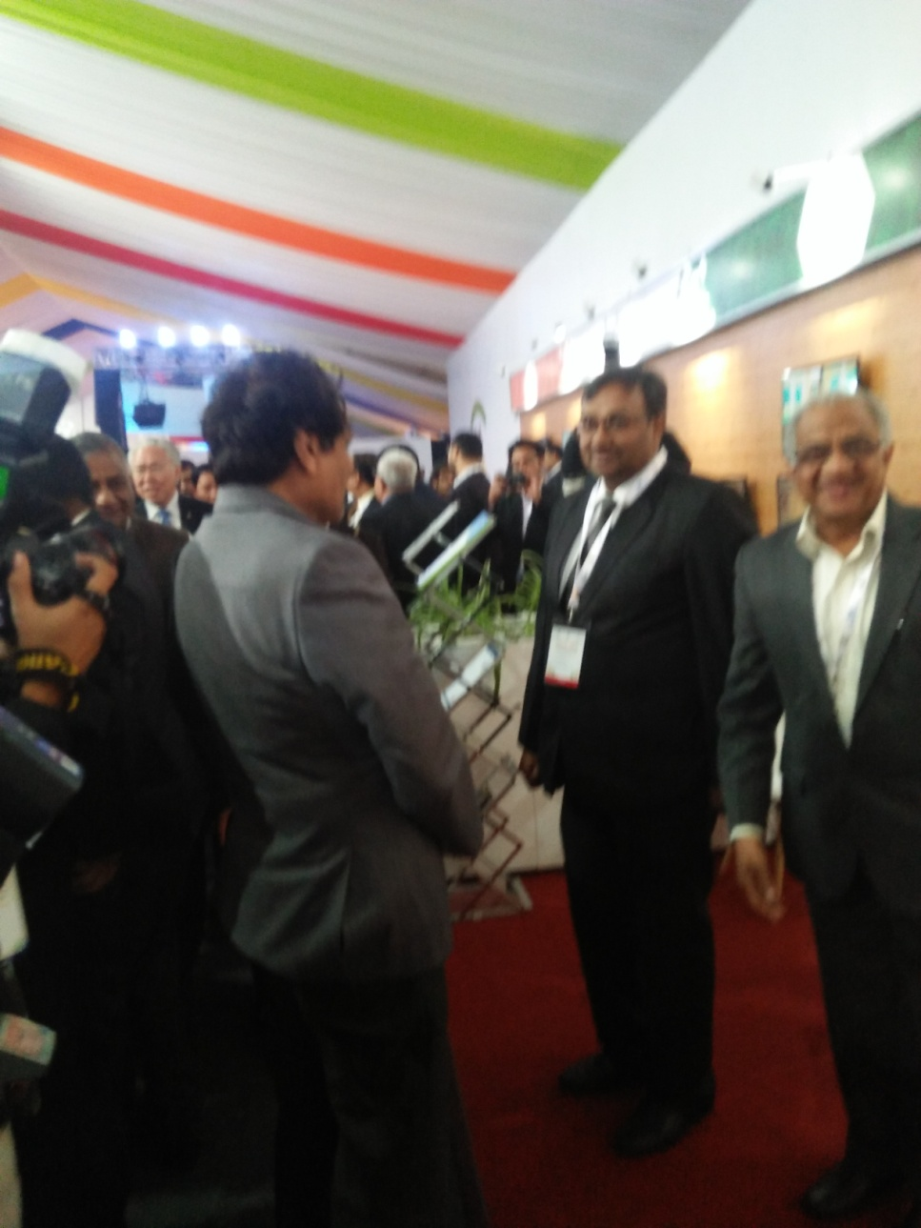

Hon’ble CIM visit at Chemical (Agrochem & Cosmetics) Stall during ‘ASEAN – INDIA Investment Meet & Expo’ held on 22nd -23rd January, 2018 at The Ashok Hotel, New Delhi

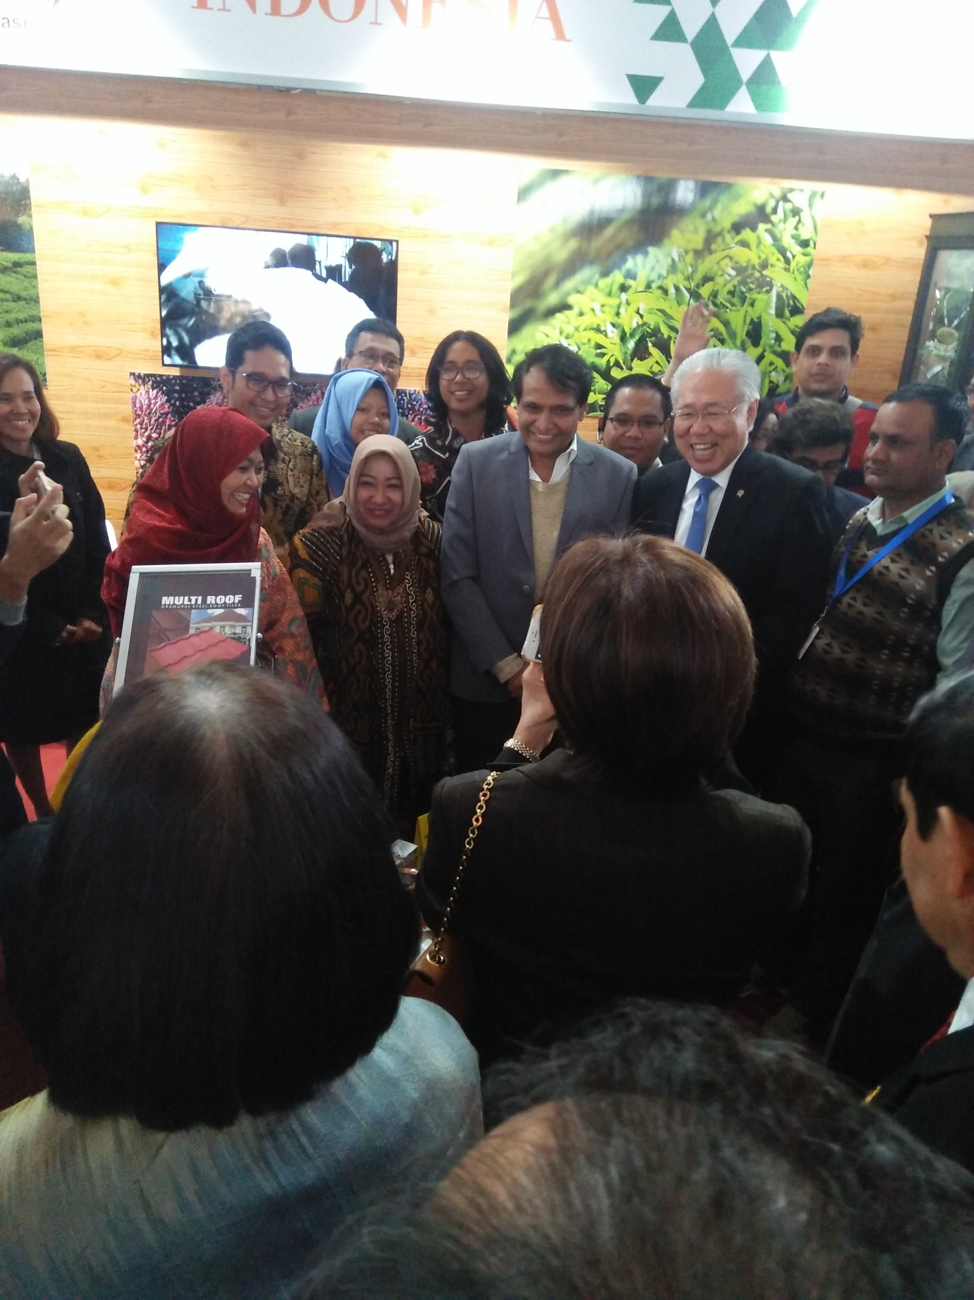

Hon’ble CIM visit at ‘ASEAN – INDIA Investment Meet & Expo’ held on 22nd -23rd January, 2018 at The Ashok Hotel, New Delhi

