Brief Report-
Interactive meeting on 16/01/2018 at Chemexcil Mumbai office regarding issues faced by Importers (HS Code Classification & FSSAI)

The council had received representations from the member-exporters citing import related issues pertaining to FSSAI mapping and HS code classifications of items specially under Chapter 29 which is leading to harassment/ DRI/ SIB related problems causing import related delays and impacting exports.

An interactive meeting of the concerned member-exporters was organised at our Mumbai Office to consolidate the major issues and decide on further action/ or meeting with the appropriate authority along-with few of the members.

This meeting was chaired by Shri S. G Bharadi- ED and attended by other officers of the council. From industry, the meeting was attended by around 15 participants.

The participants deliberated about the issues being faced while importing items especially under chapter 29. The FSSAI mapping of dual-use items imported for non-food applications leads to wastage of time in getting NOC and also involves transaction costs.

Considering the issues faced, the council shall represent these issues to the concerned in MoF, DoC, FSSAI etc for redressal.

In this regard, all the participants were requested to send us detailed representation/ further details in next 2-3 days with HS codes, items names etc and issues faced. This will enable us build a case and also enclose the representation for reference.
Glimpses of the Interactive meeting on 16/01/2018 at Chemexcil Mumbai office regarding issues faced by Importers (HS Code Classification & FSSAI)

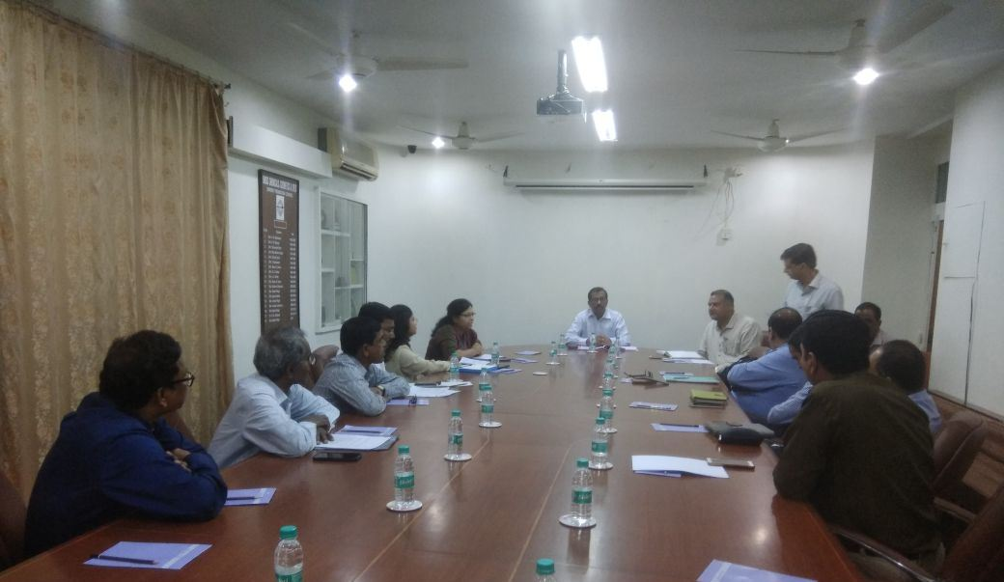
Mr. S.G Bharadi-ED interacting with participants during the interactive meeting on import related issues at Chemexcil Mumbai office on 16/01/2018

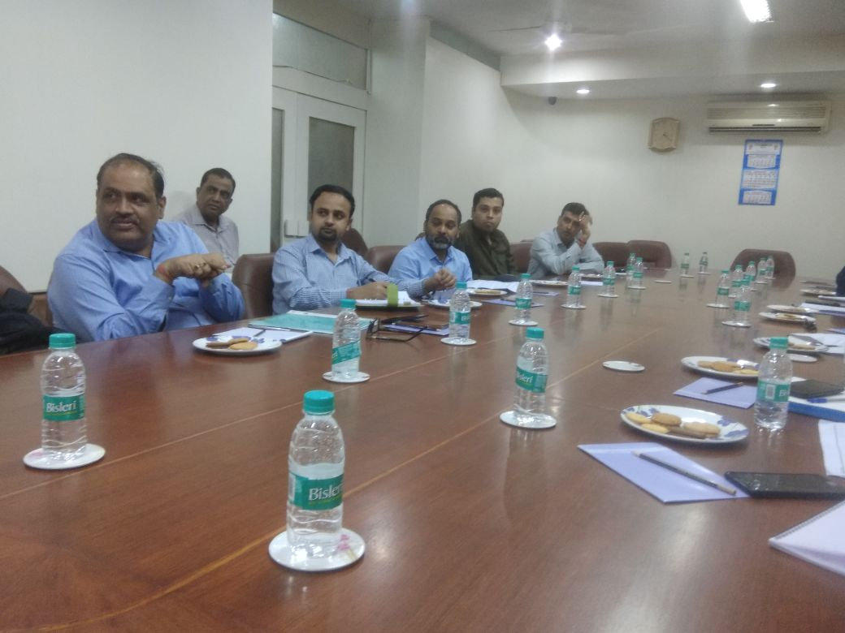
View of participants during the meeting

