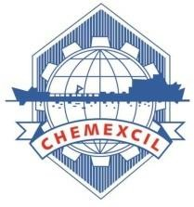

CHEMEXCIL

REPORT
Indo Beauty Jakarta
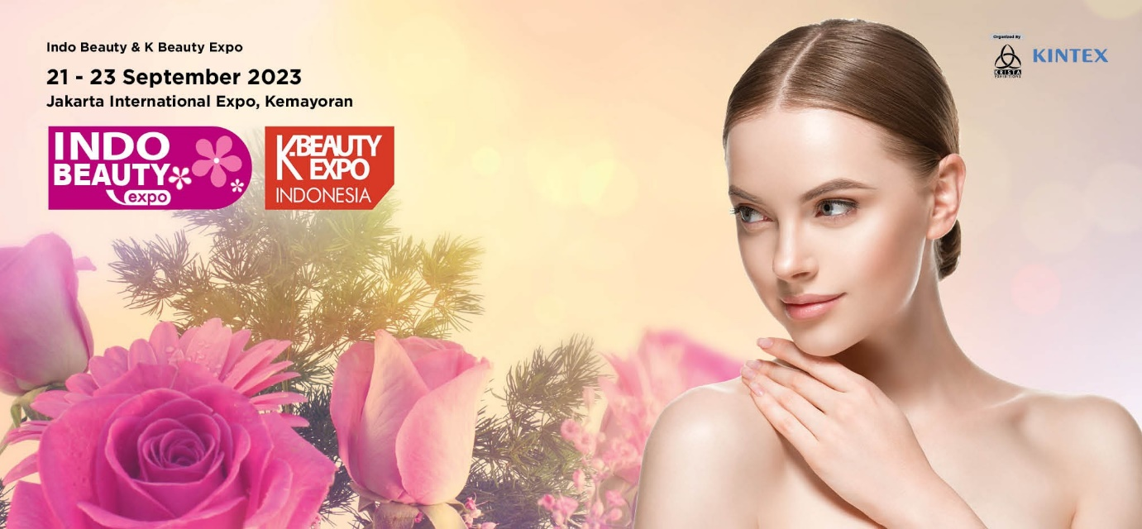

21st-23rd September, 2023 Jakarta, Indonesia

CHEMEXCIL

Basic Chemicals, Cosmetics & Dyes Export Promotion Council
(Set-up by Ministry of Commerce & Industry, Government of India) Jhansi Castle, 4th Floor, 7- Cooperage Road, Mumbai – 400 001, INDIA
Tel: +91-22-22021288, 22021330, 22825861, 22020911, Fax: +91-22-22026684
Email: info@chemexcil.in Website: https://chemexcil.in Twitter: @chemexcil

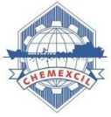
CONTENTS

SR. NO. | PARTICULARS
1 | CHAIRMAN’S DESK
2 | INDONESIA FACT SHEET, GEOGRAPHY
3 | BRIEF ABOUT EVENT INDO-BEAUTY, JAKARTA
4 | CHEMEXCIL EXPORT STATISTICS
5 | GLIMPSES OF CHEMEXCIL’S PARTICIPATION IN INDO-BEAUTY, 2023, JAKARTA, INDONESIA
6 | LIST OF CHEMEXCIL PARTICIPANTS
7 | SCAN COPY OF BUSINESS CARDS OF VISITORS
8 | REGIONAL OFFICE CONTACT DETAILS

CHAIRMAN’S DESK

Basic Chemicals, Cosmetics & Dyes Export Promotion Council, is Popularly known as CHEMEXCIL (www.chemexcil.in) was established in the year 1963 by the Ministry of Commerce & Industry, Government of India with the objective of promoting Dyes & Dye Intermediates,Organic & Inorganic chemicals, Agro Chemicals, Soaps, Detergents, Cosmetics, Toiletries, Essential Oils, Castor Oils, etc. CHEMEXCIL with a membership base of over 3500 provides free services as a reliable single point source of contact to help buyers in sourcing from India.

CHEMEXCIL provides a wide spectrum of services to Trade and Industry and acts as a catalyst for the growth of India’s Chemicals trade. It has an extensive infrastructure as well as marketing and information facilities that are
available by both exporters and importers.

The total export performance of the items covered by the Council for April 2022 to March 2023 was USD 23781 Million as against USD 24313 Million in the previous year registering a decline of 2.19 %.

Indonesia is a good market especially for Inorganic, Organic, and Agrochemicals. In value terms, the total export performance of the items covered under the purview of Chemexcil to Indonesia for the year 2022- 23 was USD 571.53 million registering decline of 18.94 % on previous year of exports to Indonesia out of which, exports of Dyes & Dye Intermediate, accounted for USD
92.18 million, Basic Inorganic, Organic Chemicals including Agrochemicals is USD 435.99 million, Cosmetics, Soaps, Toiletries and Essential oils is USD 39.36 million Friends, the Indo Beauty Jakarta 2023 is a significant event for the beauty industry in Indonesia and the region. It is the 13th edition of the event and it will be held at the JIExpo Kemayoran in Jakarta from 21st -23rd September
2023. The event is expected to attract over 150 exhibitors from Indonesia and around the world, and over 730 visitors. This event will provide a platform for businesses in the beauty industry to showcase their products and services to a large audience. It is also an opportunity for businesses to network with other industry players, learn about the latest trends, and build partnerships.

By participating in this event my fellow Indian Cosmetic exhibitors can see the latest products and services, learn about the latest trends, and meet with industry experts. This can all help you to stay motivated and inspired in your work.
I encourage you to attend the Indo Beauty Jakarta 2023 event. It is a great opportunity to learn about the latest trends, meet with industry experts, and get inspired and motivated.

I am sure that this exhibition would provide a window of opportunity to our cosmetic exporting community to clinch attractive business deals and would also offer a vibrant platform to show-case their manufacturing capabilities for fructification of the “Make in India” program of the Government of India.

I wish all the participants and visitors at Indo beauty Jakarta 2023 a grand success

Chairman’s Office:
M/s. Jayant Agro-Organics Ltd.,
701, Tower ‘A’ Peninsula Business Park, Senapati Bapat Marg, Lower Parel West, Mumbai 400013
With warm regards,

ABHAY UDESHI
Chairman, CHEMEXCIL

BRIEF of INDONESIA

Indonesia is the largest archipelago in the world. It consists of five major islands and about 30 smaller groups. The islands are located at a crossroads between two oceans, the Pacific and Indian Oceans, and straddles two continents, Asia and Australia/Oceania. Its strategic location in maritime Southeast Asia has always shaped the cultural, social, political and economic life of the country, which only gained independence from the Netherlands in 1949.

Influenced for centuries by Indian culture, which brought Hinduism and Buddhism, the archipelago gradually adopted Islam between the 13th and 16th centuries.
The Dutch began colonizing Indonesia in the early 17th century; Imperial Japan occupied the islands from 1942 to 1945.
Indonesia declared independence shortly before Japan surrendered to Allied forces. Still, it took four years of sometimes brutal fighting, interrupted negotiations and UN mediation before the Netherlands agreed to transfer sovereignty in 1949.

Current issues include: Poverty reduction, improving education, preventing terrorism, consolidating democracy after four decades of authoritarianism, implementing economic and financial reforms, curbing corruption, reforming the criminal justice system, combating climate change, and controlling infectious diseases, especially those of global and regional significance. In 2005, Indonesia reached a historic peace agreement with armed separatists in Aceh, which led to democratic elections in Aceh in December 2006. In Papua, Indonesia continues to face low-intensity armed resistance from the separatist Free Papua Movement. (Ref. https://www.nationsonline.org/oneworld/indonesia.htm#:~:text=Indonesia%20is%20the%20largest%20archipelago,%2C%20Asia%20and%20Australia%2FOceania.)

GEOGRAPHY

Location:

Indonesia, officially the Republic of Indonesia, is an island nation in Southeast Asia and Oceania between the Indian and Pacific oceans. It consists of over 17,000 islands, including Sumatra, Java, Sulawesi, and parts of Borneo and New Guinea

Area:

- Total: 1,904,569 sq km
- Land: 1,811,569 sq km
- Water: 93,000 sq km

Climate:

Tropical; hot, humid; more moderate in highlands

Natural resources:

Petroleum, tin, natural gas, nickel, timber, bauxite, copper, fertile soils, coal, gold, silver

Population:

279,476,346 (2023 est.)

Economic overview

One of the fastest growing economies and largest in Southeast Asia; upper middle-income country; human capital and competitiveness phase of its 20-year development plan; COVID-19 reversed poverty reduction trajectory; strengthening financial resilience.

Real GDP (purchasing power parity)

- $3.246 trillion (2021 est.)
- $3.131 trillion (2020 est.)
- $3.197 trillion (2019 est.)

Real GDP per capita

- $11,900 (2021 est.)
- $11,500 (2020 est.)
- $11,900 (2019 est.)

INDO-BEAUTY 2023 EXPO, JAKARTA, INDONESIA

ABOUT THE EXHIBITION:

The Indo Beauty Jakarta Exhibition: A Celebration of Indonesian Beauty and Culture

The Indo Beauty Jakarta Exhibition is a showcase of the best of Indonesian beauty products, services, and culture. The event, which is held annually in Jakarta, Indonesia, attracts visitors from all over the world who are interested in learning more about and experiencing Indonesian beauty.

The exhibition features a wide range of exhibitors, including cosmetics companies, skincare brands, hair salons, spa resorts, and fashion designers. Visitors can browse the booths to learn about the latest products and trends, and to sample a variety of products and services.

In addition to the exhibition, the Indo Beauty Jakarta Exhibition also features a variety of other events, such as fashion shows, beauty workshops, and cultural performances. These events provide visitors with an opportunity to learn more about Indonesian culture and to experience the beauty of Indonesia firsthand.

The Importance of Event

The Indo Beauty Jakarta Exhibition is an important event for the Indonesian beauty industry. It provides a platform for Indonesian brands to showcase their products and services to a global audience. The event also helps to promote Indonesian beauty culture to the world.

The exhibition is also important for the Indonesian economy. It attracts visitors from all over the world who spend money on hotels, restaurants, and shopping. The event also creates jobs in the beauty industry and in related sectors.

Highlights

Some of the highlights of the Indo Beauty Jakarta Exhibition include:

- A wide range of exhibitors from all over Indonesia and the world
- The latest products and trends in Indonesian beauty
- Fashion shows, beauty workshops, and cultural performances
- Opportunities to learn more about Indonesian culture and to experience the beauty of Indonesia firsthand

The Indo Beauty Jakarta Exhibition is a must-attend event for beauty lovers of all ages. The event offers something for everyone, from the latest products and trends to cultural performances and fashion shows. Visitors will leave the exhibition feeling inspired and refreshed, and with a better understanding of Indonesian beauty culture.

The wide range of exhibitors. Visitors can find everything from cosmetics and skincare products to hair salons and spa resorts. There are also a number of fashion designers who showcase their latest collections at the event.

The Indo Beauty Jakarta Exhibition is a unique and exciting event that celebrates the best of Indonesian beauty and culture. Visitors to the exhibition can browse a wide range of products and services from Indonesian brands, learn about the latest trends and techniques, and experience Indonesian culture firsthand. The Indo Beauty Jakarta Exhibition is a must-attend event for anyone who is interested in beauty and culture.

The Inauguration Ceremony was organized on 21st September at 11:30 hrs. (Indonesia Time). The Indian Pavilion was inaugurated by HE Shri Sandeep Chakravorty, Ambassador of India to Jakarta, Indonesia, Embassy of India, along with Dr. Uday Kharote Cosmetic Panel Chairman and Shri Prafulla Walhe, Deputy Director, CHEMEXCIL.

Later Shri Sandeep Chakravorty, Ambassador of India to Jakarta, Indonesia, Embassy of India had visited Indian Member Exporter Stalls. The members-exporters were happy to interact with the visiting dignitaries.

Total 12 Cosmetics member-exporters from CHEMEXCIL participated in this Exhibition with total area of 246 sqmtr. Indo-Beauty Expo attracted cosmetics industry experts from Indonesia region of which 600 were trade visitors. A total of 150 exhibitors from 4 countries presented their product portfolio at Hall C1, JI Expo International.

EXPORT STATISTICS

CHEMEXCIL'S EXPORT PERFORMANCE FOR THE YEARS 2020-21, 2021-22 & 2022-23
Value in USD Million
Chapter No./Panel | 2020-21  (Actual) | 2021-22  (Actual) | %  Growth | 2022-23  (Provisional) | % Growth
(32) Dyes & (29) Dye  Intermediates | 2491.45 | 3243.77 | 30.20 | 2606.30 | -19.65
(32) Dyes | 2345.86 | 3078.62 | 31.24 | 2422.81 | -21.30
(29) Dye Intermediates | 145.58 | 165.15 | 13.44 | 183.49 | 11.11
(28) Inorganic, (29) Organic &  (38) Agro Chemicals | 12271.44 | 17609.60 | 43.50 | 17194.58 | -2.36
(28) Inorganic chemicals | 1055.00 | 1766.59 | 67.45 | 2174.51 | 23.09
(29) Organic chemicals | 7636.74 | 10946.37 | 43.34 | 9640.83 | -11.93
(38) Agro chemicals | 3579.69 | 4896.64 | 36.79 | 5379.25 | 9.86
(33) Cosmetics, (34) Toiletries & (33) Essential oils | 1852.92 | 2284.60 | 23.30 | 2714.60 | 18.82
(33) Cosmetics, (34) Toiletries | 1618.88 | 1973.96 | 21.93 | 2408.34 | 22.01
(33) Essential oils | 234.04 | 310.64 | 32.73 | 306.27 | -1.41
(15) Castor oil | 917.24 | 1175.50 | 28.16 | 1265.64 | 7.67
Total | 17533.04 | 24313.47 | 38.67 | 23781.13 | -2.19
Source: DGCI&S

CHEMEXCIL's Export to INDONESIA for the years 2020-21, 2021-22 & 2022-23
Value in USD Million
Chapter No./Panel | 2020-21 (Actual) | 2021-22 (Actual) | % Growth | 2022-23 (Provisional) | % Growth
(32) Dyes & (29) Dye Intermediates | 87.75 | 126.74 | 44.43 | 92.18 | -27.27
(32) Dyes | 86.10 | 125.31 | 45.54 | 91.48 | -27.00
(29) Dye Intermediates | 1.65 | 1.42 | -13.89 | 0.70 | -50.58
(28) Inorganic, (29) Organic & (38) Agro chemicals | 430.19 | 536.27 | 24.66 | 435.99 | -18.70
(28) Inorganic chemicals | 29.63 | 62.77 | 111.83 | 44.54 | -29.04
(29) Organic chemicals | 340.42 | 382.28 | 12.30 | 283.27 | -25.90
(38) Agro chemicals | 60.14 | 91.22 | 51.68 | 108.18 | 18.60
(33) Cosmetics, (34) Soaps, Toiletries and (33) Essential oils | 53.79 | 38.85 | -27.79 | 39.36 | 1.32
(33) Cosmetics, (34) Toiletries | 36.78 | 34.03 | -7.48 | 36.88 | 8.36
(33) Essential oils | 17.01 | 4.81 | -71.70 | 2.48 | -48.48
(15) Castor Oil | 1.65 | 3.21 | 95.30 | 4.01 | 24.63
TOTAL | 573.38 | 705.06 | 22.97 | 571.53 | -18.94
Source: DGCI&S

Source: DGCI&S

CHEMEXCIL COMMODITYWISE EXPORT TO ASEAN FOR THE YEAR 2020-21, 2021-22 & 2022-23

Value in USD Million
PANEL | 2020-21  (Actual) | 2021-22  (Actual) | %  Growth | 2022-23  (Provisional) | % Growth
(32) Dyes & (29) Dye Intermediates | 318.19 | 403.22 | 26.72 | 323.31 | -19.82
(32) Dyes | 312.11 | 395.90 | 26.85 | 320.73 | -18.99
(29) Dye Intermediates | 6.08 | 7.32 | 20.31 | 2.58 | -64.78
(28) Inorganic, (29) Organic &  (38) Agro chemicals | 1420.70 | 1939.30 | 36.50 | 1975.50 | 1.87
(28) Inorganic chemicals | 159.96 | 295.08 | 84.47 | 304.92 | 3.34
(29) Organic chemicals | 955.96 | 1210.44 | 26.62 | 1260.39 | 4.13
(38) Agro chemicals | 304.78 | 433.77 | 42.33 | 410.18 | -5.44
(33) Cosmetics, (34) Soaps, Toiletries and (33) Essential oils | 204.71 | 194.00 | -5.23 | 222.03 | 14.45
(33) Cosmetics, (34) Toiletries | 176.98 | 180.46 | 1.97 | 209.74 | 16.22
(33) Essential oils | 27.73 | 13.54 | -51.19 | 12.29 | -9.21
(15) Castor Oil | 38.41 | 48.15 | 25.34 | 61.07 | 26.84
TOTAL | 1982.01 | 2584.67 | 30.41 | 2581.91 | -0.11
Source: DGCI&S
3 YRS EXPORT TO TOP ASEAN COUNTRIES

Value in USD
Million
COUNTRY | 2020-21  (Actual) | 2021-22  (Actual) | %  Growth | 2022-23  (Provisional) | % Growth
MALAYSIA | 439.23 | 591.41 | 34.65 | 650.86 | 10.05
INDONESIA | 573.38 | 705.06 | 22.97 | 571.53 | -18.94
SINGAPORE | 290.71 | 408.93 | 40.67 | 522.90 | 27.87
THAILAND | 307.41 | 377.57 | 22.82 | 332.40 | -11.96
VIETNAM SOC REP | 246.52 | 350.40 | 42.13 | 326.32 | -6.87
PHILIPPINES | 75.94 | 102.03 | 34.36 | 114.09 | 11.82
MYANMAR | 40.41 | 37.02 | -8.39 | 53.23 | 43.77
CAMBODIA | 3.57 | 7.23 | 102.21 | 4.86 | -32.69
FIJI IS | 3.00 | 3.13 | 4.22 | 3.77 | 20.61
BRUNEI | 0.95 | 1.39 | 46.04 | 0.98 | -29.63
PAPUA N GNA | 0.85 | 0.48 | -43.98 | 0.97 | 103.46
LAO PD RP | 0.02 | 0.02 | -16.15 | 0.01 | -64.19
Source: DGCI&S

CHEMEXCIL'S TOP ITEMS EXPORT TO INDONESIA FOR THE YEAR 2022-23

Sr.No | HS Code | Description
1 | 38089290 | OTHERS FUNGICIDE NES
2 | 28030010 | CARBON BLACKS
3 | 38089199 | OTHER INSECTICIDE NES
4 | 38089400 | DISINFECTANTS
5 | 38089390 | OTHER HERBICIDES-ANTI-SPROUTING PRODUCTS
6 | 38089135 | CIPERMETHRIN TECHNICAL
7 | 32041761 | PIGMENT GREEN 7 (PATHALOVYANINE GREEN)
8 | 32041751 | PIGMENT BLUE 15 (PATHALOCYANINE BLUE)
9 | 38089132 | QUINALPHOS
10 | 28112200 | SILICON DIOXIDE
11 | 32041680 | REACTIVE BLACKS
12 | 28416100 | POTASSIUM PERMANGANATE
13 | 34021190 | OTHERS(E.G.ALKYLSULPHATES,TECHNICAL DODECYLBENZENE-SUL
14 | 28151110 | FLAKES OF SODIUM HYDROXIDE(NAOH),SOLID
15 | 29181690 | OTHER GLUCONIC ACID ITS SALTS AND ESTERS
16 | 32041982 | FOOD COLOURING YELLOW 4 (TARTRAZINE)
17 | 32041650 | REACTIVE BLUES
18 | 38089340 | PLANT-GROWTH REGULATORS
19 | 29252990 | OTHER IMINES AND THEIR DERIVTVS, SALTS THEREOF
20 | 38089122 | METHYL BROMIDE
21 | 32041759 | OTHERS PIGMENT BLUE
22 | 15153090 | CASTOR OILANDITS FRCTNS OTHR THN EDBLE GRADE
23 | 34021900 | OTHR ORNGC SRFCE-ACTV AGNTS W/N FOR RTL SL
24 | 33049910 | CREAMS FACE (EXCL TURMARIC)
25 | 33029011 | SYNTHETIC PERFUMERY COMPOUNDS

GLIMPSES OF CHEMEXCIL’S PARTICIPATION IN

INDO-BEAUTY EXPO INDONESIA 2023

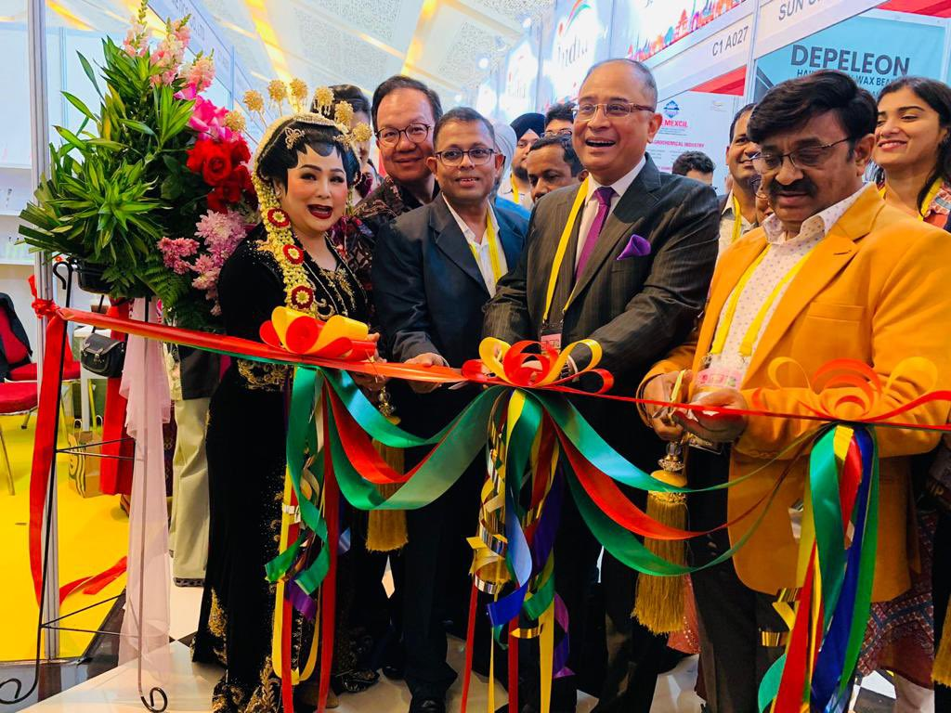

The Inauguration Ceremony was organized on 21st September, 2023 at 1130 hrs. (Indonesia Time).The Indian Pavilion was inaugurated by His Excellency Shri Sandeep Chakravorty, Ambassador of India to Jakarta, Indonesia, Embassy of India along with Dr. Uday Kharote Cosmetic Panel Chairman and Shri Prafulla Walhe, Deputy Director, CHEMEXCIL.
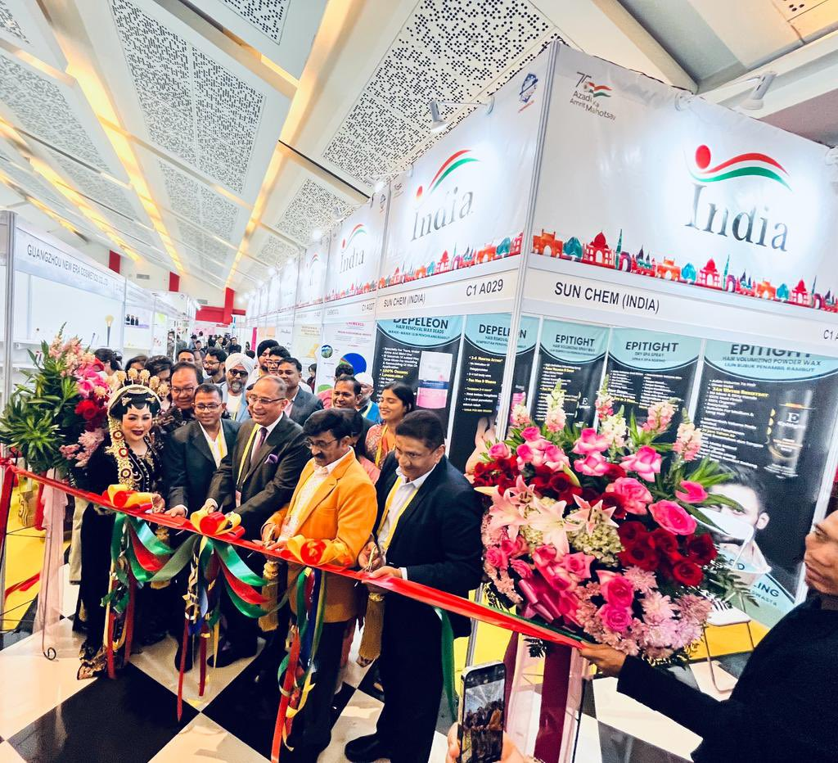

His Excellency Shri Sandeep Chakravorty, Ambassador of India to Jakarta, had visited Indian Members Exporter Stalls, the members-exporters were happy to interact with the visiting dignitaries.
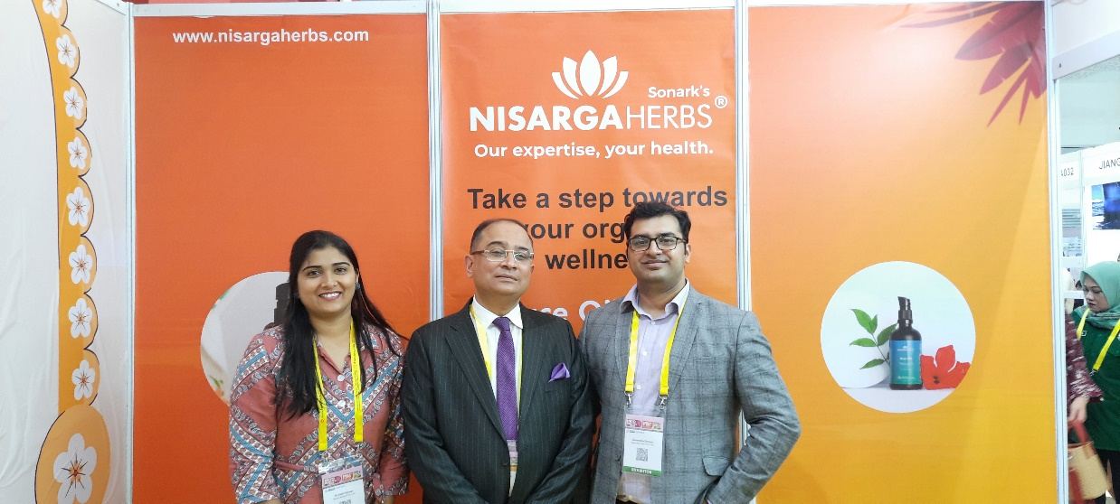
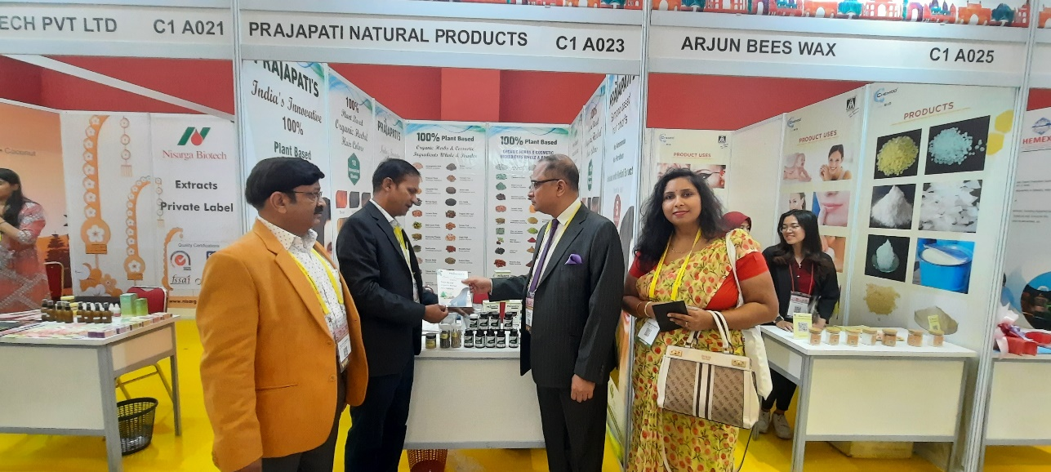
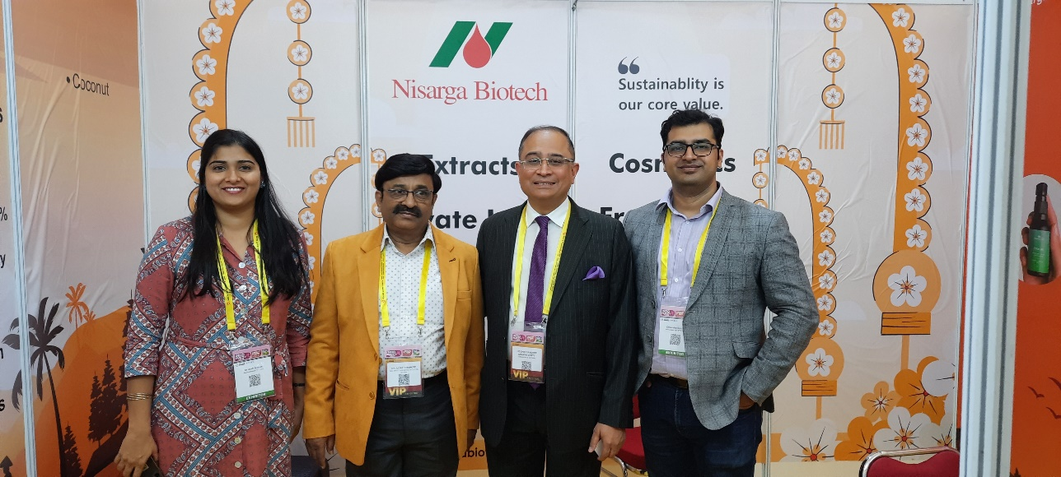

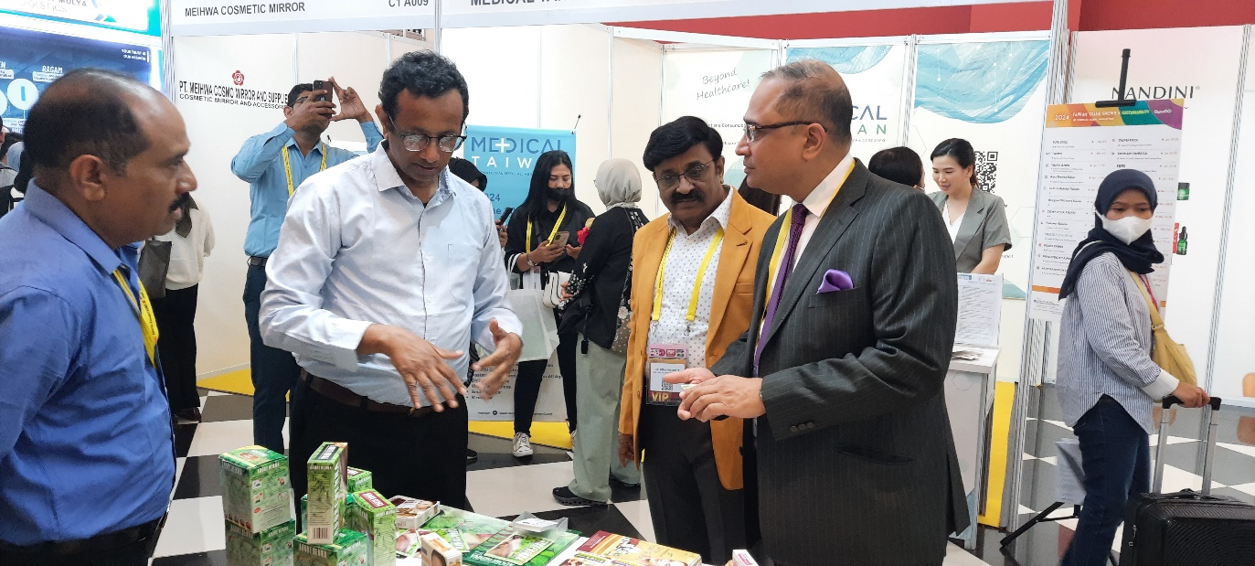

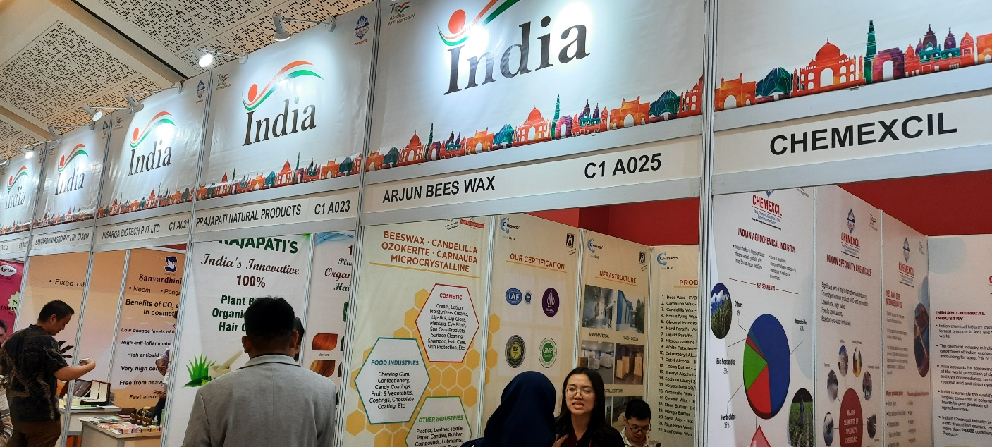

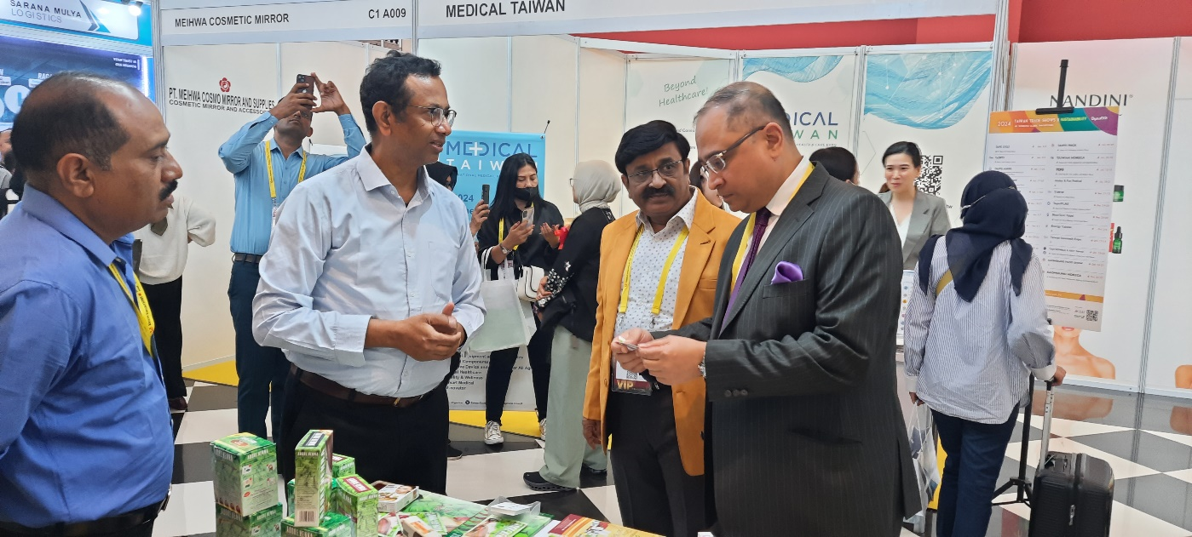

Indo Beauty Expo Indonesia 2023

LIST OF CHEMEXCIL PARTICIPANTS
CHEMEXCIL

SR. NO | NAME AND ADDRESS OF THE COMPANY | CONTACT PERSON & DESIGNATION | PRODUCTS MANUFACTURED WITH HS CODE | IEC NUMBER
1 | THREE N PRODUCTS PVT. LTD.  24A, SHIVAJI MARG, NAJAFGARH | JAGJIT SINGH, KUMAR INDER SINGH NARANG  EXPORT MANAGER | SHAMPOO 33051090  HENNA POWDER 33059040  SOAP 34011941  LOTION CREAM SCRUB 33049990 | 597013861
2 | ARJUN BEES WAX INDUSTRIES  PLOT NO 831 & 844B G.I.D.C.WAGHODIA  DIST.VADODARA-391760  GUJARAT INDIA | HARSHIT SHETH  PATNER | BEES WAX 15219010  EMUILSIFYING WAX 34049090  SHEA BUTTER 15159099  COCOA BUTTER 18040000  LIGHT LIQUID OIL 27101990 | 310089522
3 | BHAVI INTERNATIONAL PVT. LTD.  209, MEWAD, PATANWALA IND.COMPLEX, L.B.S. MARG, OPP.SHREYAS CINEMA, GHATKOPAR(W),  MUMBAI - 400086 | MR. SHRIKANT BIYALA  BU HEAD – COSMETICS  PERSONAL CARE  CHEMICALS AND CUSTOM SYNTHESIS | PERSONAL CARE INGREDIENTS & CHEMICALS 293399 292690 292239 292529 290729  HAIR DYE CHEMICALS 292151 292211 293190  SPECIALTY CHEMICALS 294200 292229  INORGANIC & ORGANIC CHEMICALS 280300, 280610 280700, 281129 281511, 281700  DYES & CHEMICALS 320190 320411  SOAPS & SURFACTANTS 340111 340219 | 0393028135
4 | C&I MARKETING PVT LTD  1898/18, GF, GOVINDPURI EXTENSION, NEW DELHI - 110019 | Mr. RAKESH BANDOONI  GENERAL MANAGER | Hair Dyes - henna & herb based 330590  Henna - pure Herb 140410  Peel Off Mask 330499  Herbal Powders for Beauty 330499  Cosmetics - Skin & Hair Care 330499 | 0507027477
5 | HUSNA FLAVOURS & FRAGRANCES PVT LTD  NOOR ESTATE” No.18, 7TH CROSS H-SIDDAIAH ROAD, BANGALORE-560027. | AHMED SALEEM  DIRECTOR | INCENSE FRAGRANCES 33029011  FINE FRAGRANCES 33029011  COSMETIC FRAGRANCES 33029011  FABRIC CARE 33029011  ORIENTAL FRAGRANCES 33029011 | 0407029745
6 | INSTO COSMETICS PRIVATE LIMITED  Plot C-11, Units No.19, 47 to 50, NICE, Satpur  Nashik Maharashtra 422007 India | Dr. Uday Kharote  Director | Hair Removal Cream 330790  Skin Bleach Cream 330499  Lip Balm 330499  Pigmentation Cream 330499  De Tan Cream 330499  Foaming Scrub Gel 330499  Tissue Nourishment Lotion 330499  Moisturizing Cream 330499  Anti-Ageing Cream 330499  Sunscreen Lotion 330499 | 3105012893
7 | MONTEX INDUSTRIES  D – 58 EAST OF KAILASH, NEW DELHI - 110065 | ROHIT GUPTA  PROPRIETOR | Henna Powder, Natural Henna, Herbal Henna, Neutral Henna 140490  Hair Dyes, Hair Colors 330590  Black Henna, Brown Henna, Chestnut Henna 330590  Red Henna, Burgundy Henna 330590  Indigo Powder 121190 | 0516952595
8 | NANDINI HERBAL CARE PVT LTD  S-201, SIGNETURE COMPLEX, OPP SUVARNA  BUNGLOWS , THALTEJ, AHMEDABAD | MR HITESH LIMBANI  MANAGER | FACIAL KITS 33049990  SOAP 34011190  OIL 33059019 | 0802007490
9 | NISARGA BIOTECH PVT LTD  J-2/1 ADDL.M.I.D.C. SATARA 415004 MS INDIA | Arati Devendra Soman  Executive, International business | Oils & Extracts 130219  Holistic Extracts 130219  Cosmetic ingredients 130219 | 3100007522
10 | PRAJAPATI NATURAL PRODUCTS  PLOT NO. 46 , KHASRA NO. 28/1 , RAMESHWAR NAGAR  SECTOR F, BASNI 1 , JODHPUR 342005, RAJASTHAN, INDIA | GANESH RAM PRAJAPATI  PROPRIETOR | 100% PLANT BASED HAIR COLORS 33059040  HENNA COLOR 14041019  ESSENTIAL OIL 33019079  ASHWAGANDHA TABLET 13021919  NUTRACEUTICAL SUPPLEMENT TABLET 21069099  MORINGA TABLET 30049099  TURMERIC TABLET 21069099  PSYLLIUM HUSK TABLET 12119032 | 1316502007
11 | SANVARDHINI AGRO PVT.LTD  PLOT NO. M-14 ADDITIONAL MIDC, SATARA | MR. DEVENDRA GIRISH SOMAN  DIRECTOR | Plant growth Promoters 380893  Organic Fertilizer 310100  Botanical pesticides 380899  Botanical fungicides 310100 | 3197034180
12 | SUN CHEM (INDIA)  119, GURU GOBIND SINGH INDUSTRIAL  ESTATE, OFF. WESTERN EXP. HIGHWAY, NR. JAY COACH, GOREGAON EAST, MUMBAI-400063, MAHARASHTRA, INDIA | MR.VIMALKUMAR BALWANTRAI TOLIA  PROPRIETOR | Hair removal cream spray 33049990  Hair removal wax 33049990  Hair removal roll on wax 33049990  Hair volumizing powder wax 33059090  Hair setting spray 33059090  Hair Dry Spa Spray 33059990 | 0394031024

CHEMEXCIL
SCAN COPY OF BUSINESS CARDS OF VISITORS
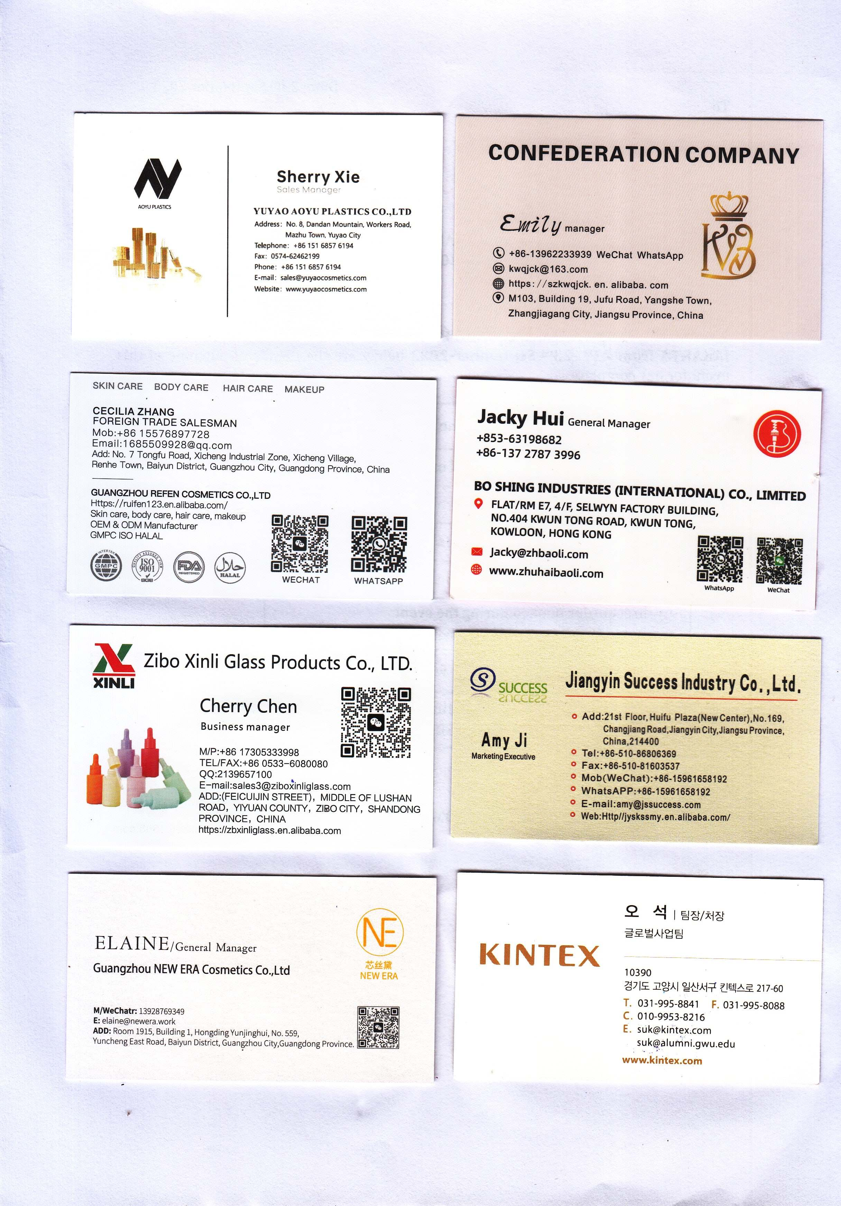

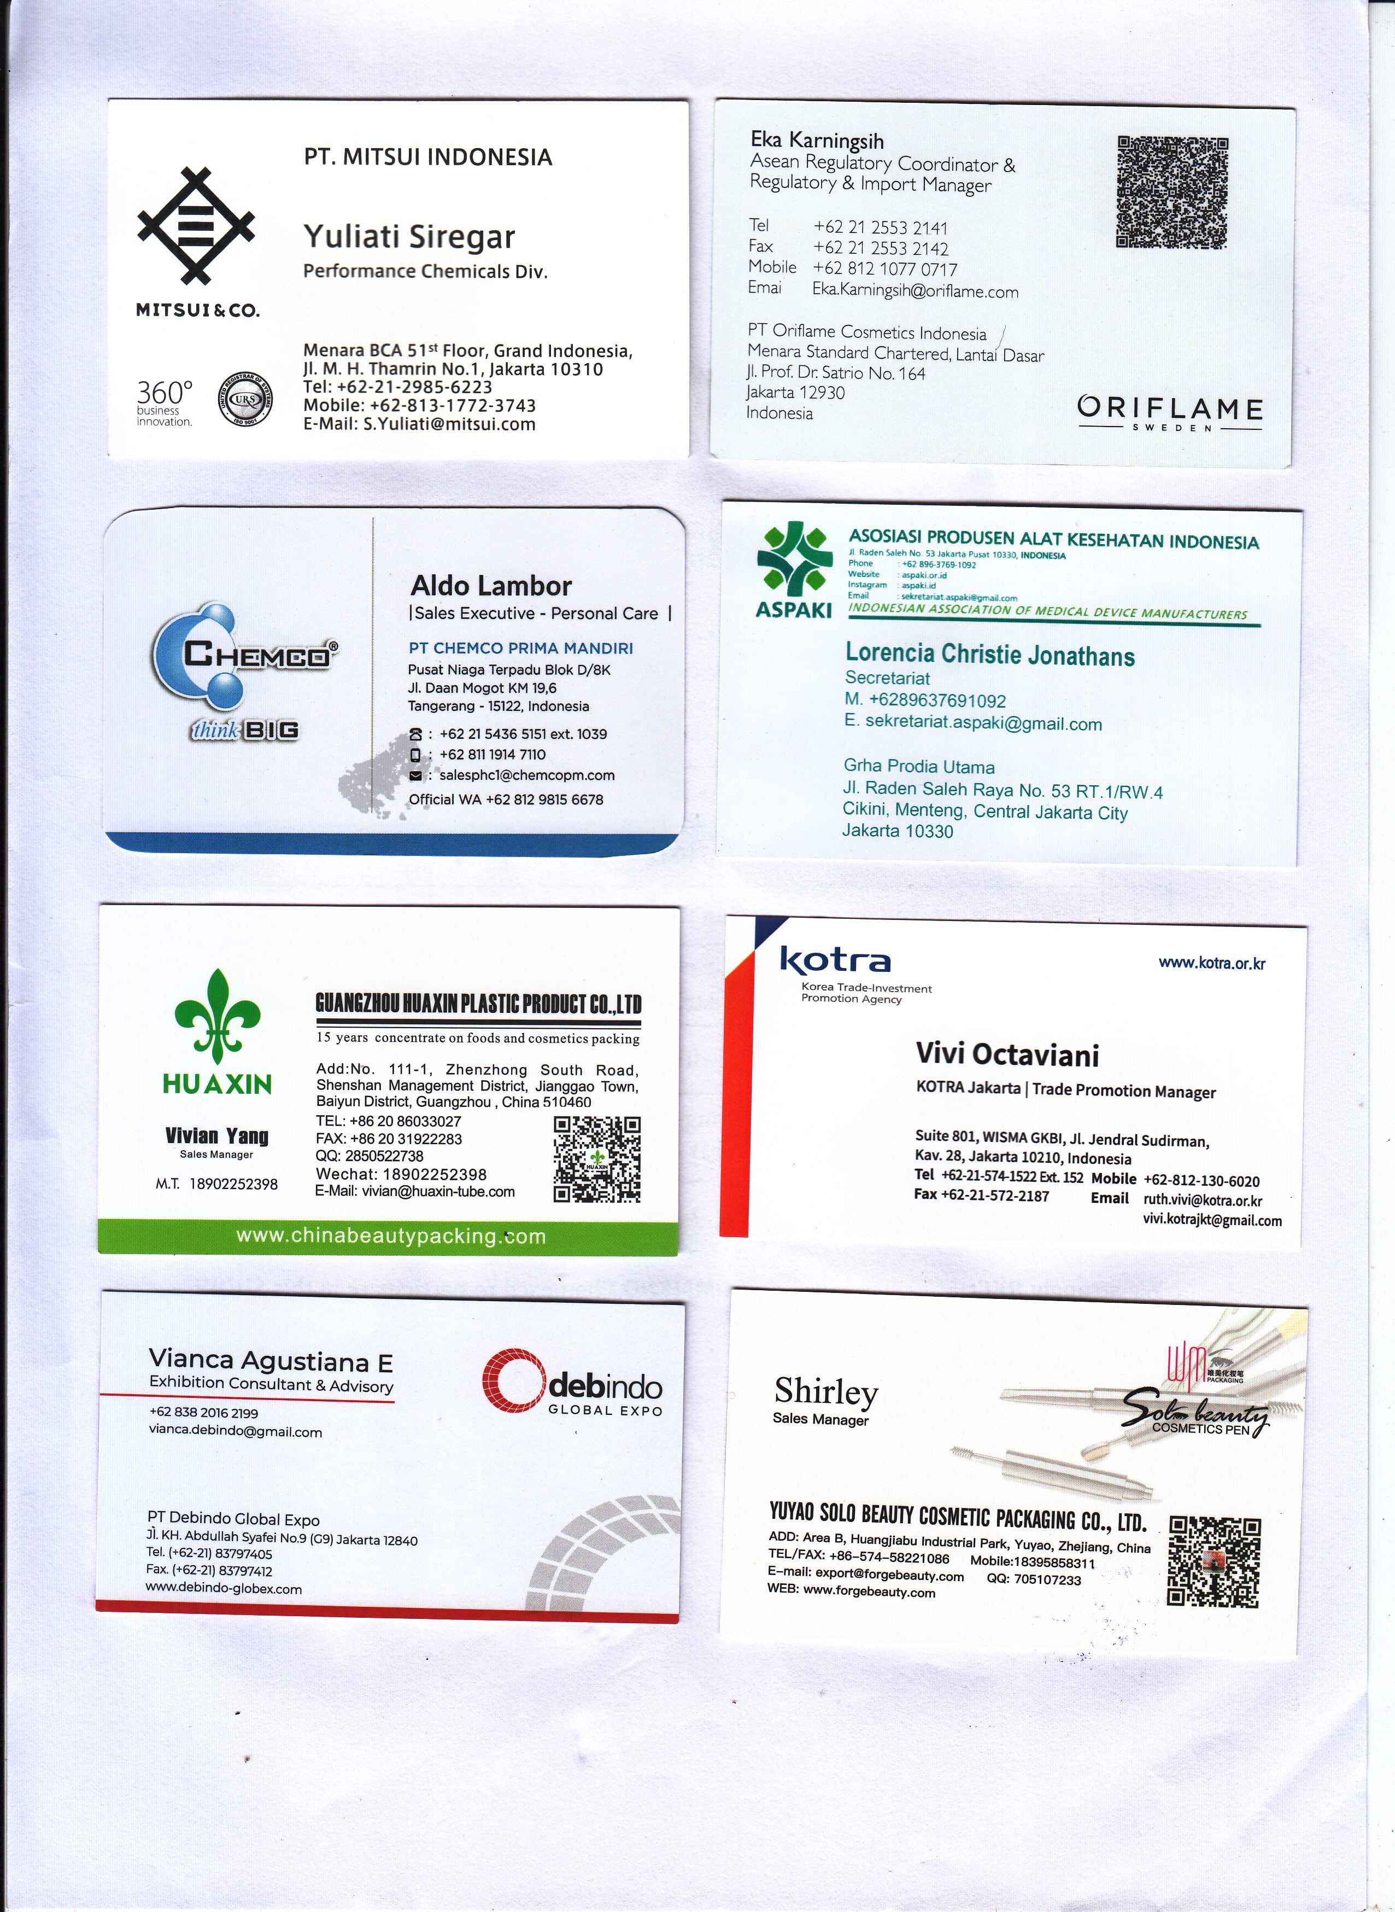
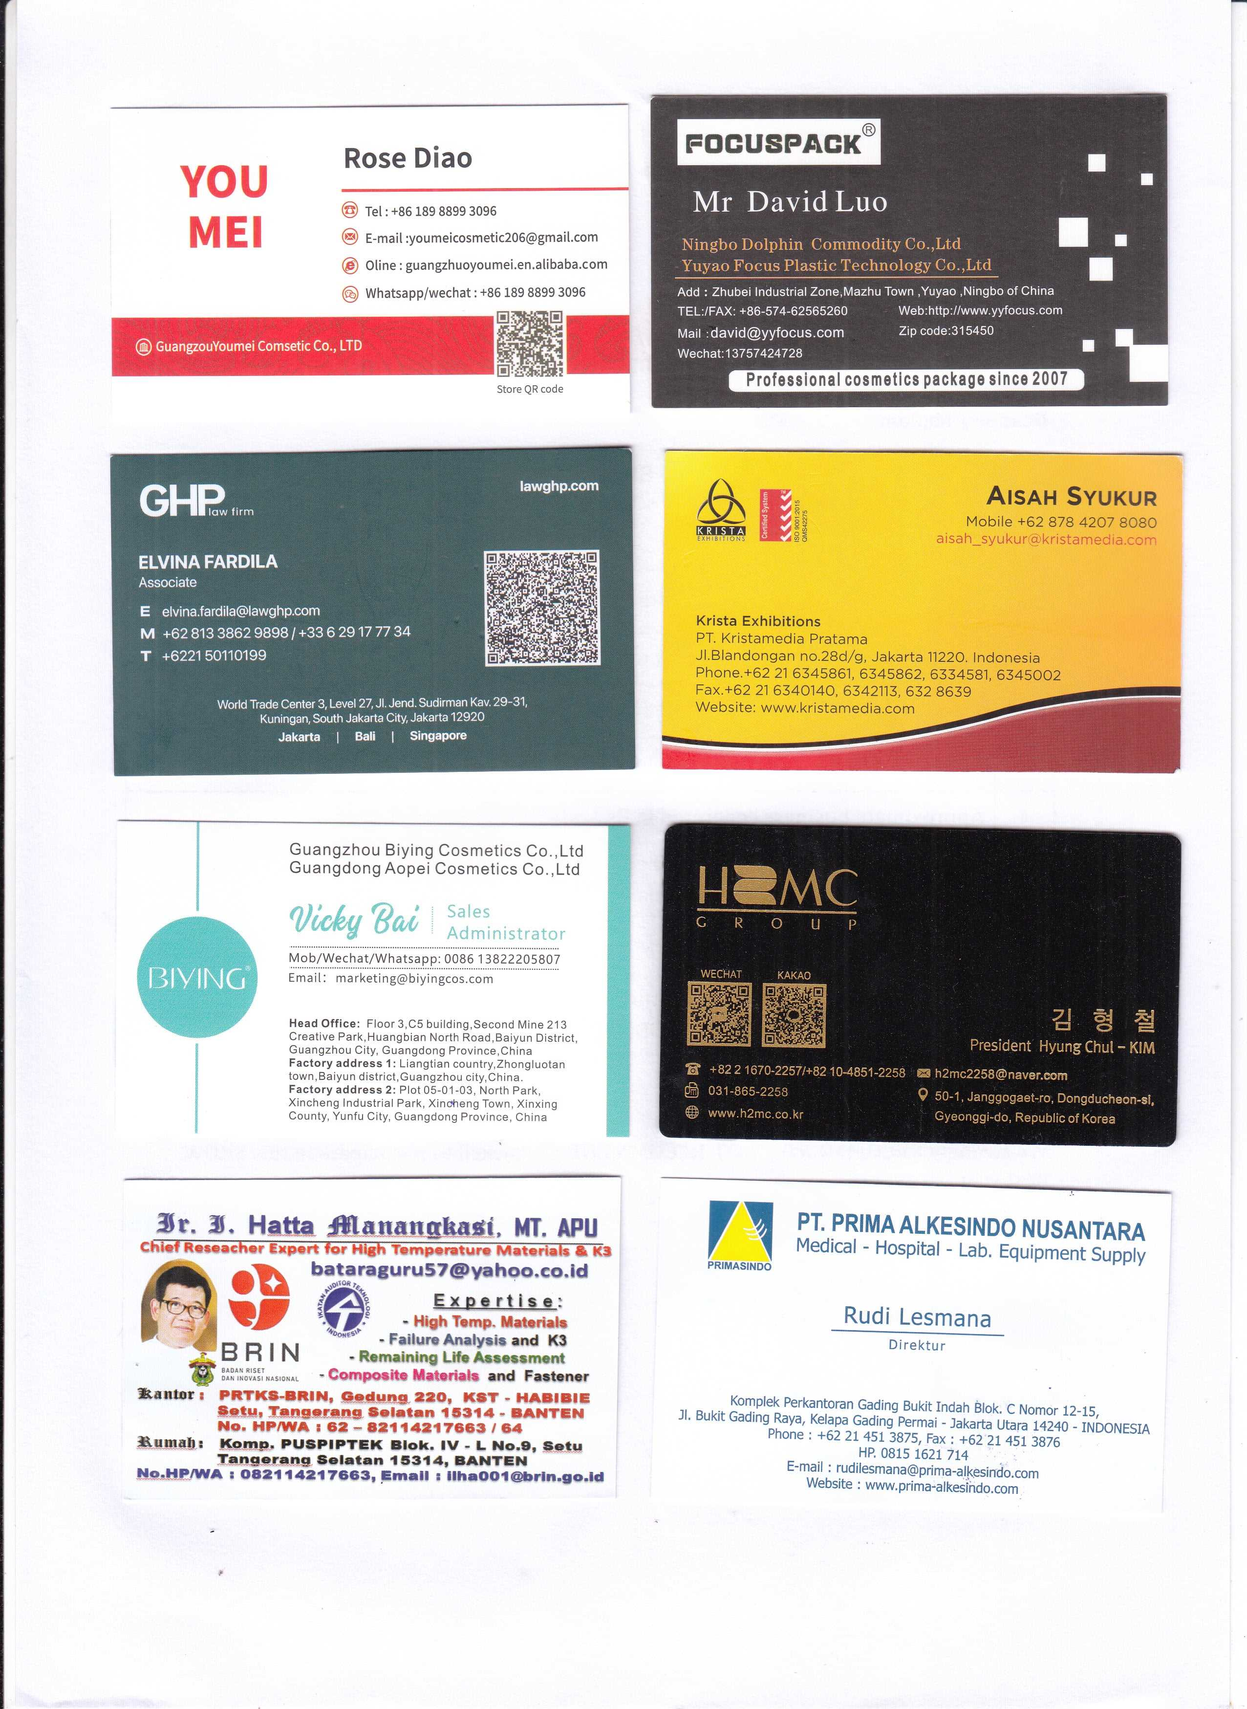

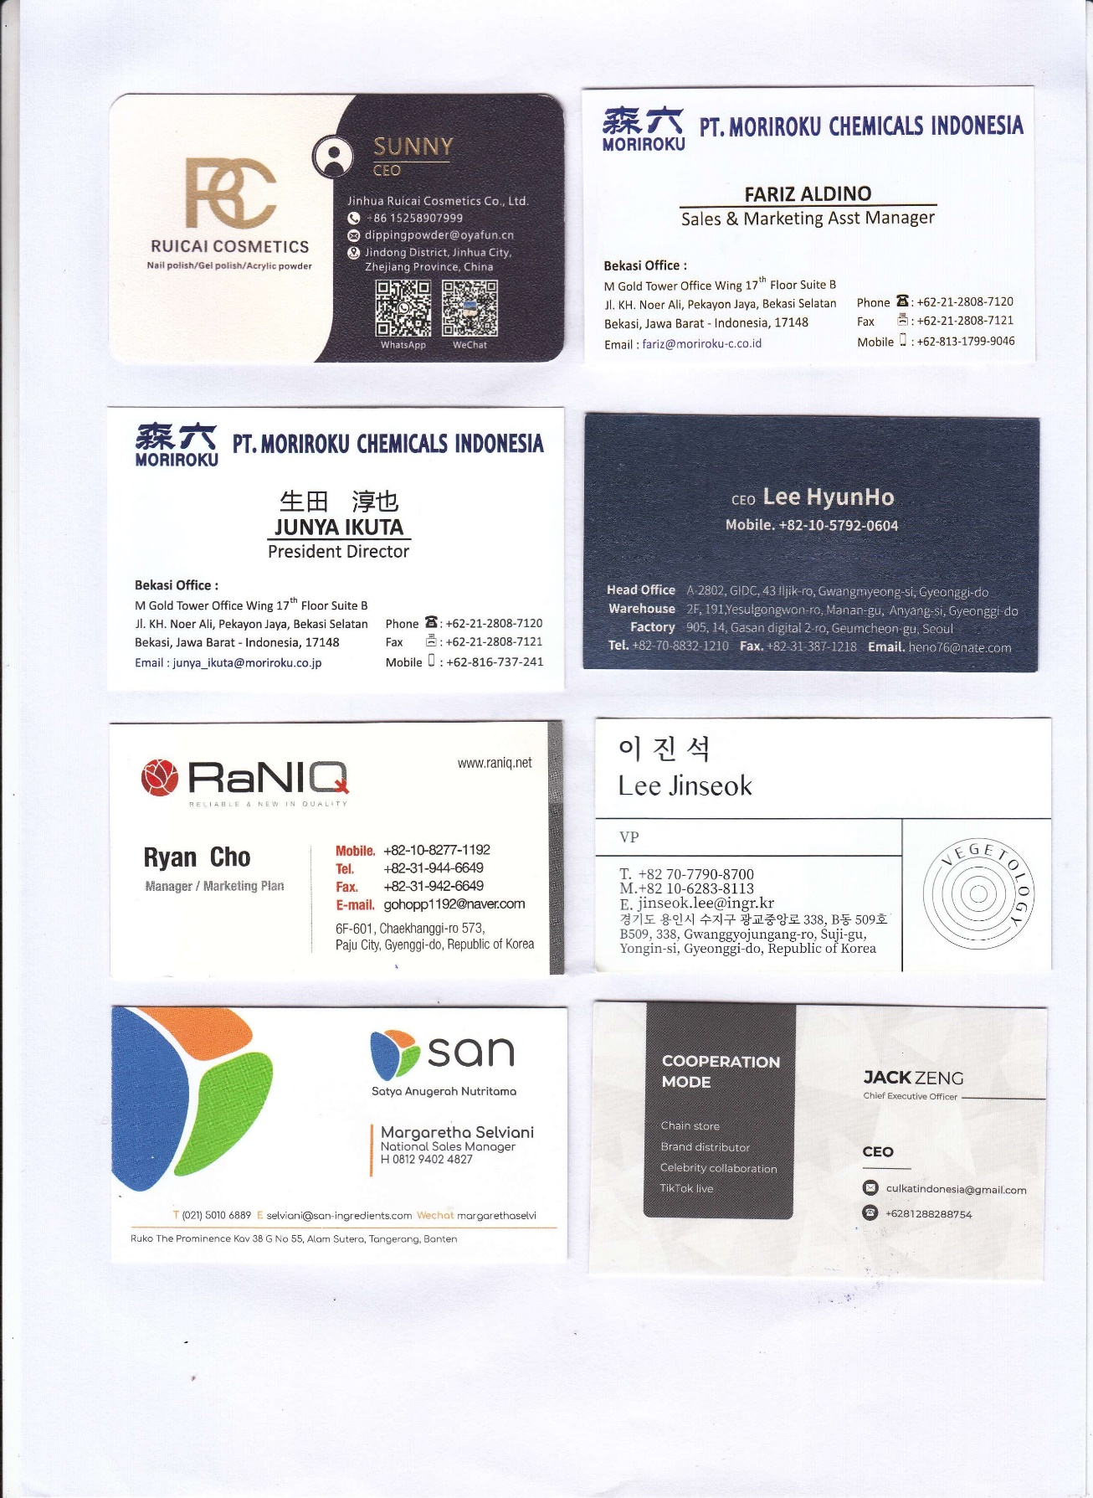
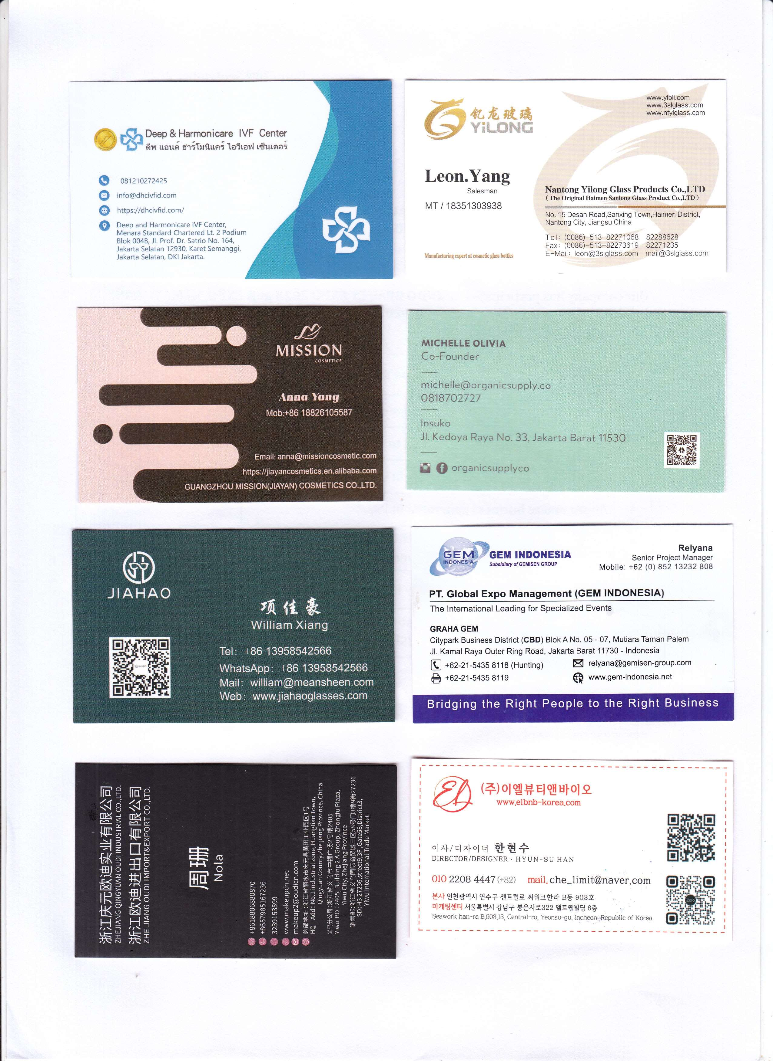

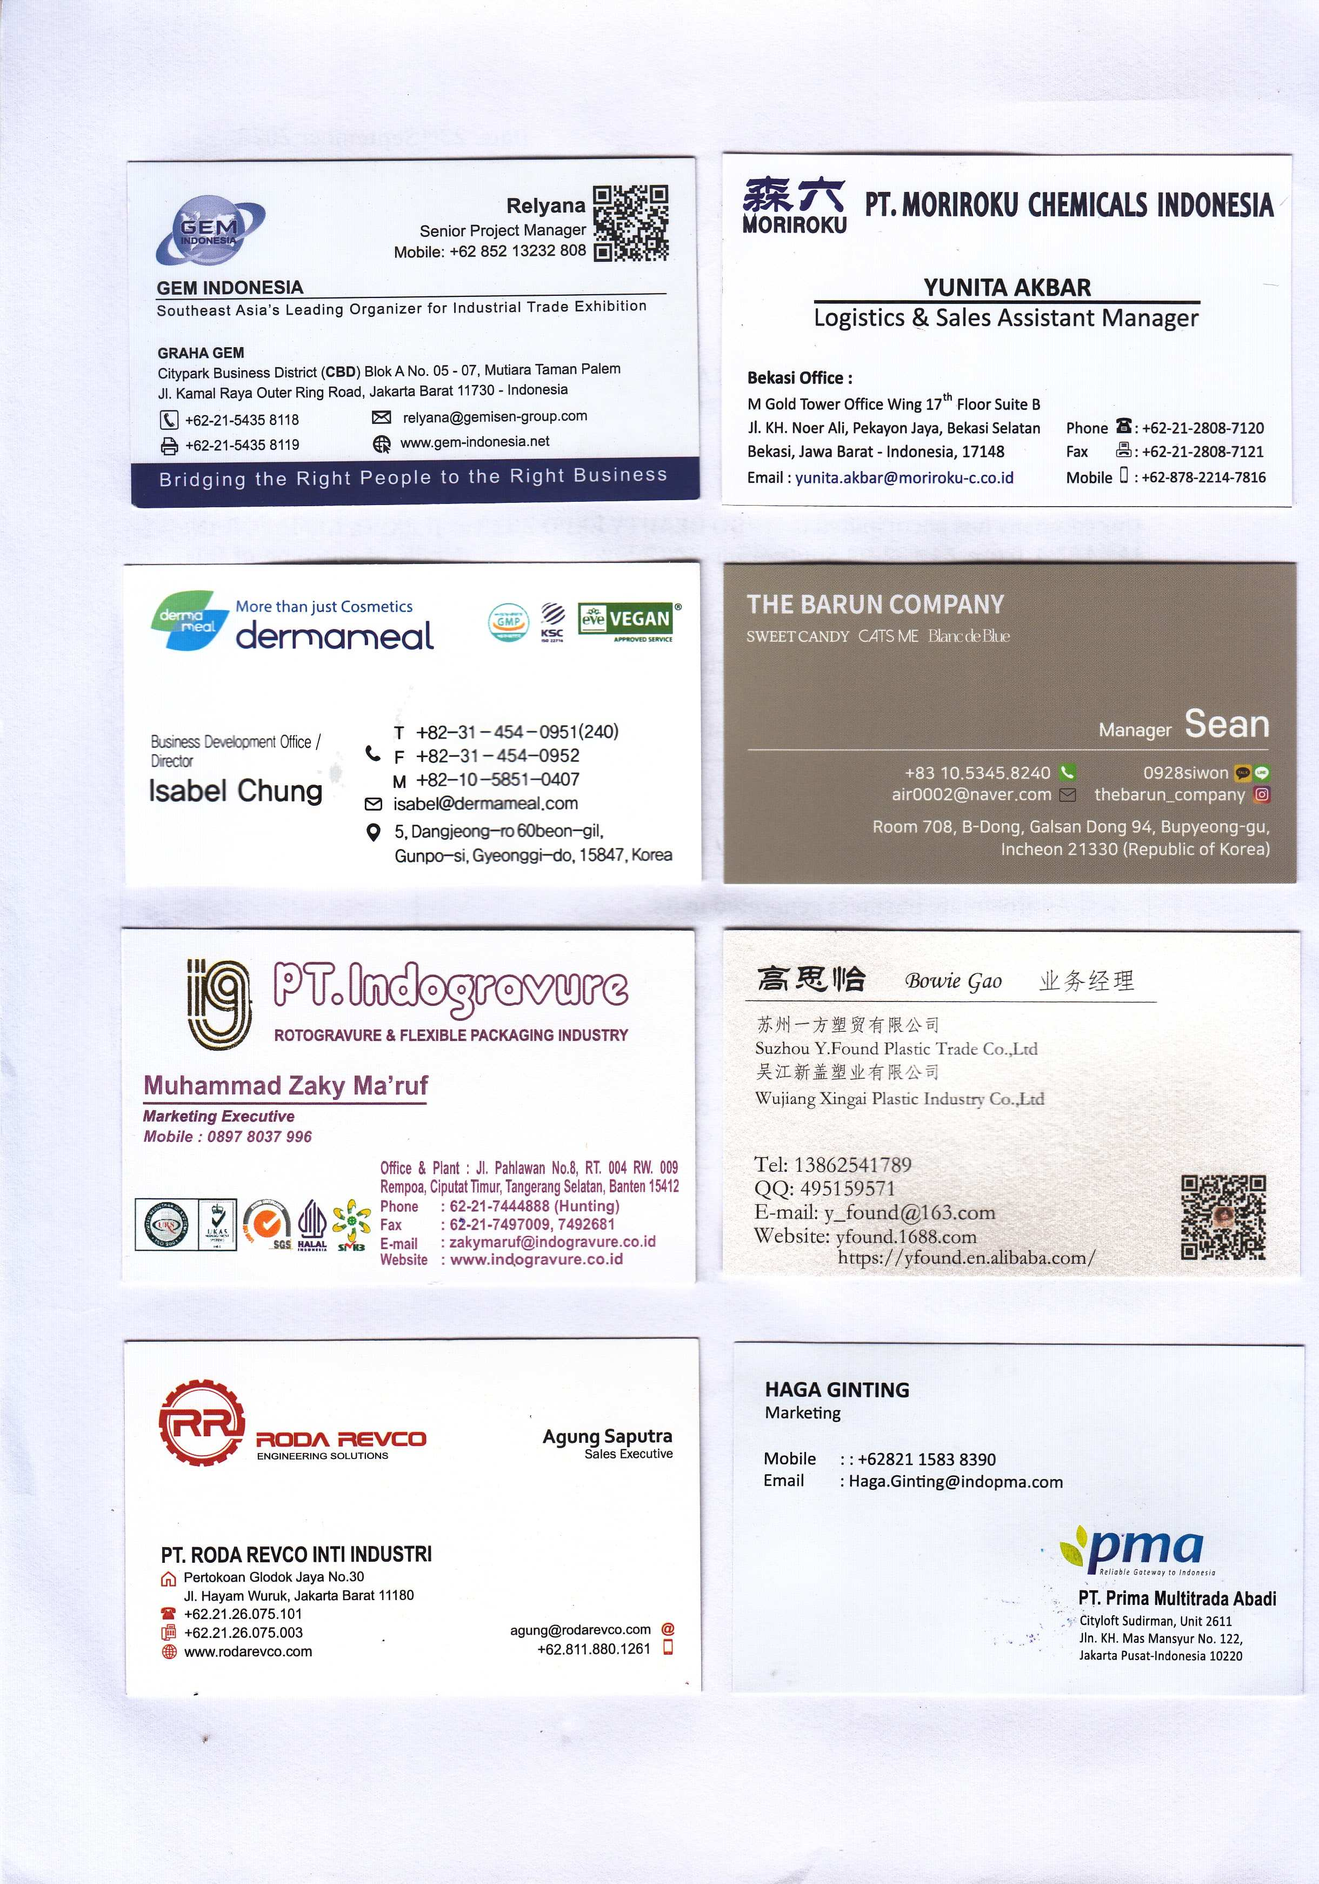

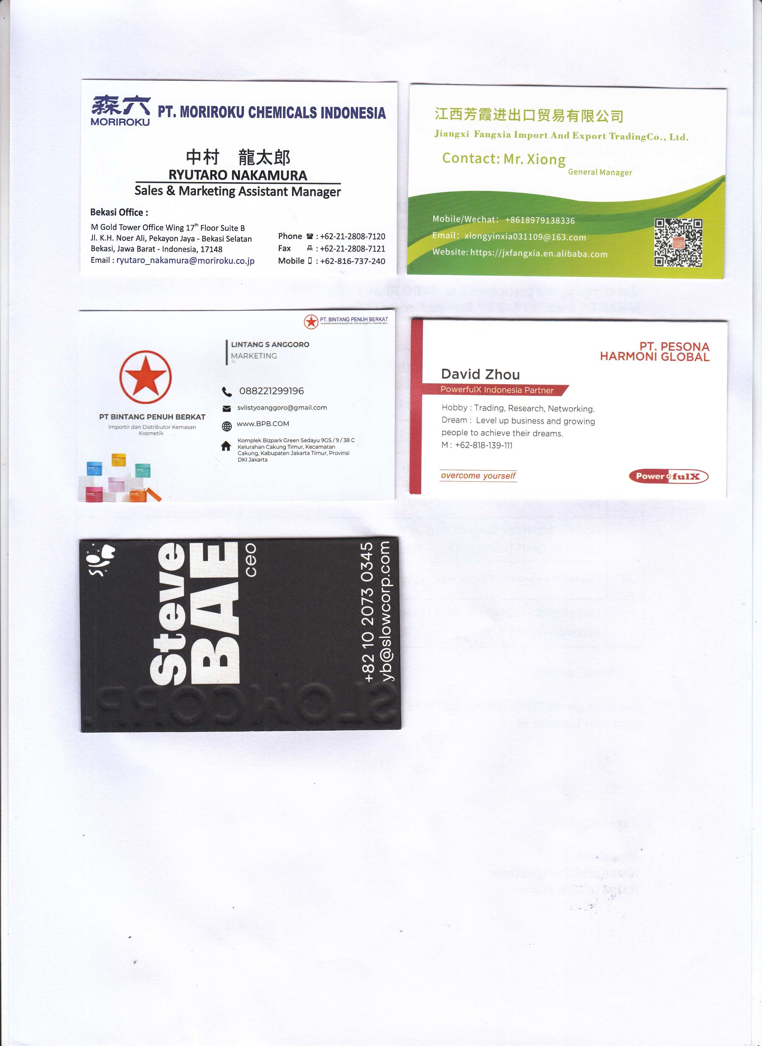

CHEMEXCIL
(Set-up by Ministry of Commerce & Industry, Government of India)

HEAD OFFICE

MUMBAI
Jhansi castle, 4th floor,

7-Cooperage Road, Mumbai- 400 001, INDIA
Phone: +91 22 22021288 / 330 / 22825861.
Fax: +91 22 22026684
Email: info@chemexcil.in

REGIONAL OFFICES

AHMEDABAD

901, Karma Complex,
Opp Mahalaxmi Municipal Market,

Near Mahalaxmi Cross Road, Paldi, Ahmedabad-380 007.
Phone: +91-79-26650223
Fax: +91-79-26651224
Email: roahmedabad@chemexcil.in

NEW DELHI

C-53, 5th floor, Himalaya House, 23, K.G. Marg, New Delhi -110 001
Phone: +91-11-23359890 / Fax: +91-11-23359891
Email: rodelhi@chemexcil.in

BENGALURU

Manipal Centre, 6th Floor, Unit No S-610, #47, Dickenson Road, Bangalore – 560042
Phone: +91-80-25580447 / Fax: +91-80-25580446
Email: robengaluru@chemexcil.in

KOLKATA

“KRISHNA Building”, 8th Floor, Room No. 812,
224A, Acharya Jagadish Chandra Bose Road, Kolkata - 700017
Phone: +91 -33-22805791 / Fax: +91 -33-22875562
Email: rokolkata@chemexcil.in

