Brief report
on
ONE DAY TRAINING PROGRAMME
ON
Importance of Process Safety including Health & Safety Awareness,
in general, in Chemical Industry”
on 08/02/2020 at The Green Environment Services Co-Operative Society Ltd (GESCSL)

Chemical hazards are disastrous and can lead to serious consequences like deaths, injuries, heavy damages and losses if not controlled and managed properly. Workers handling highly hazardous materials, should take utmost precaution and care to safeguard their lives and health, as any small slippage may lead to dangerous consequences. GIDC Vatva is catering around 650 chemical Manufacturing units.

In this regards, Chemexcil, in association with Gujarat Safety Council (GSC) and The Green Environment Services Co-Operative Society Ltd (GESCSL) had organised one day Training Program on “Importance of Process Safety including Health & Safety Awareness, in general, in Chemical Industry” at The Green Environment Services Co-Operative Society Ltd (GESCSL) ,Vatva , Ahmedabad on 8th February 2020.

The objective of this Training programme was to motivate and educate the workforce of an industry to develop safety awareness and to inspire and encourage them to make significant and contributory change in their attitude towards safety, which will improve safety standards and increase productivity.
Mr. Shankerbhai Patel, Chairman, The Green Environment Cooperative society was the Chief Guest. Mr. Bhupendrabhai Bhai Patel, Western Regional Chairman- CHEMEXIL was the Guest of Honor. Mr. C C Vora, Deputy Director Industrial Safety & Health, Government of Gujarat, Mr. S T Desai from Gujarat Safety council, Mr. Yogesh Parikh, President, GDMA, Directors of GESCSL and Board Members of Vatva Industries Associations were among the other dignitaries who graced the occasion.
The Seminar was conducted by renowned Safety Expert Mr. A N Trivedi who has more than 40 years of experience in the field of health & safety.

More than 150 participants took the benefits of the seminar. Certificate of participation were distributed to the participants.

Shri Deepak Davda, CEO, The Green Environment Services Co-operative Society Limited , welcomed the dignitaries on the dais and the participants to the training programme.

Shri Shanker Patel, Chairman, The Green Environment Services Co-operative Society Limited welcomed all the dignitaries on Dias by giving them mementoes.

He added that Chemical, Petrochemical and Pharma industries have more possibilities of accidents and Casualties compared to other industries. However, compared to last year (2018), the number of such incidents decrease by 20% in current year (2019).

Mr. Patel suggested industry manufacturers to take preventive steps rather than corrective measures after accidents to minimize industrial mishaps. He also requested the safety representatives to bring to notice to their management the reasons that could lead to industrial accidents.

Shri Bhupendra Patel, Regional Chairman, Western Region, Chemexcil briefed about Chemexcil and its export promotional activities. He also updated the participants about Chemexcil’s export performance for the year 2018-19. A short film about Chemexcil is also run during this training programme.

Mr. C C Vora, Deputy Director Industrial Safety & Health, Government of Gujarat (DISH) shared his immense knowledge on Industrial Safety data and emphasized on use of products with standardization. He also suggested that there should be check-list for safety compliance in each unit.

Shri S.T. Desai from Gujarat Safety Council briefed about the activities of their Council and about the faculty Shri Anil Trivedi.

Shri Yogesh Desai, President. The Gujarat Dyestuff Manufacturers’ Association (GDMA) extending vote of thanks and congratulated GESCSL, CHEMEXCIL and Gujarat State Council (GSC) for organising such informative training programme on Industrial Safety.

Mr. A N Trivedi, Safety Expert was the faculty of this Training Program, Mr. Trivedi is a free-lance consultant in the fields of Corporate Strategy, Occupational and Process Safety, Energy, Systems development and rolling out Productivity improvement tools in manufacturing units.
Mr. Trivedi who also had worked as a consultant for the World Bank and the Asian Development Bank for Energy and Environmental issues

The following topics were covered by the faculty during this training programme.
- Types of Industrial Hazards
- Hazard Control Strategies
- Risks and Accident Causing Factors
- Accident Prevention Techniques
- Precautions and Remedial measures
- Different Safety Legislations

During Presentation, many queries related to the Safety were answered satisfactorily by the faculty.

More than 140 participants from industry took the benefit of this programme.

Gujarat Safety Council has also distributed Certificate of participation and their Safety Kit to all the participants

LIST OF PARTICIPANTS
SN | NAME OF PARTICIPATE COMPANY
1 | AARTI ORGANICS
2 | ADVANCE DYESTUFFS
3 | AHMEDABAD MEGA CLEAN
4 | AKSHAR CHEM INDIA LTD
5 | ALPS CHEMICALS PVT LTD
6 | AMARDEEP DYES & INTERMEDIATES
7 | AMCA
8 | AMTEX DYECHEM
9 | ANAR CHMICALS LLP
10 | ASCENT FINE CHEM PVT LTD
11 | AVANI DYE CHEM INDUSTRIES
12 | AVID CHEM CORPORATION
13 | BALAJI INDUSTRIES
14 | BENZO PRODUCTS
15 | BHARAT COLOR CHEM
16 | BHAVIN INDSTRIES
17 | BI-KI DYES & CHEMICALS
18 | BODAL CHEMICALS LTD
19 | CHEMCLONE INDUSTRIES
20 | CHOKSI PIGEMENTS
21 | COLORANT LTD
22 | DEO PIYU INDUSTRIES
23 | DEVANSH INDUSTRIES
24 | DHANUKA AGRITECH LTD
25 | DHAVAL DYES
26 | DL INTRACHEM
27 | DYNAMIC INDUSTRIES LIMITED
28 | ESDEE PAINTS LTD
29 | EVER GREEN INDUSTRIES
30 | GNFC
31 | HEMANI INDUSTRIES LTD
32 | HINDPRAKASH GROUP OF COMPANIES
33 | INDO COL CHEM
34 | JAINIK INDUSTRIES
35 | JAY ORGANICS LTD
36 | JEMBY CHEM LTD
37 | KIRI DYES
38 | KIRI INDUSTRIES LTD
39 | MAC DYE CHEM INDUSTRIES
40 | MANGAL TEXTILE MILLS
41 | MATANGI INDUSTRIE LTD
42 | MEGHMANI INDUSTRIES LLP
43 | MEGHMANI ORGANICS LTD
44 | MODERN CHEMICALS
45 | NCR COLORS LLP
SN | NAME OF PARTICIPATE COMPANY
46 | NICHEM INDUSTRIES
47 | NISHA ENTERPRISE
48 | ORNATE INTERMEDIATES LTD
49 | P.I.INDUSTRIES LTD
50 | ROYAL CASTOR PVT LTD
51 | RONIT ENTERPRISE
54 | SHRI HARU DYES AND CHEMICALS
55 | SHUBHAM INDUSTRIES
56 | STAR DYES & INTERMEDIATES
57 | SUDEEP INDUSTRIES
58 | SUDHISH INDUSTRIES
59 | UMA POLYMERS LTD
60 | USHANTI COLOURCHEM LTD
61 | VALIANT ORGANICS
62 | VIBFAST PIGMENTS PVT LTD

GLIMPSES OF TRAINING PROGRAMME
ON
Importance of Process Safety including Health & Safety Awareness,
in general, in Chemical Industry
WELCOME OF DIGNATORIES ON DIAS BY GESCSL BOARD MEMBERS
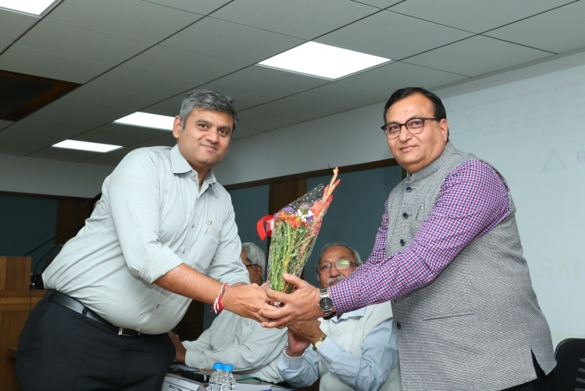
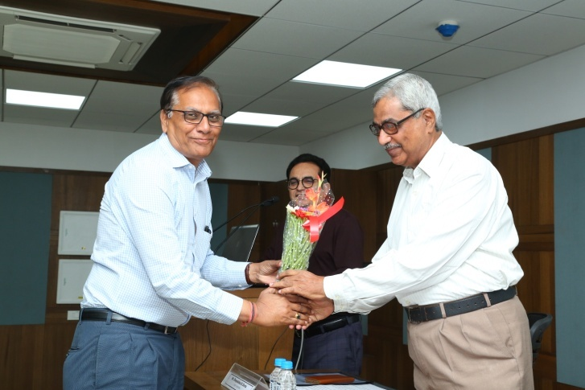
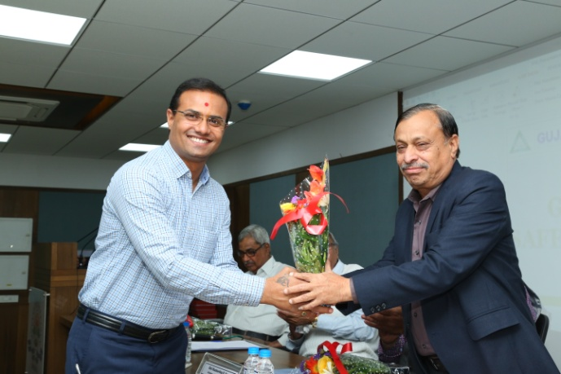
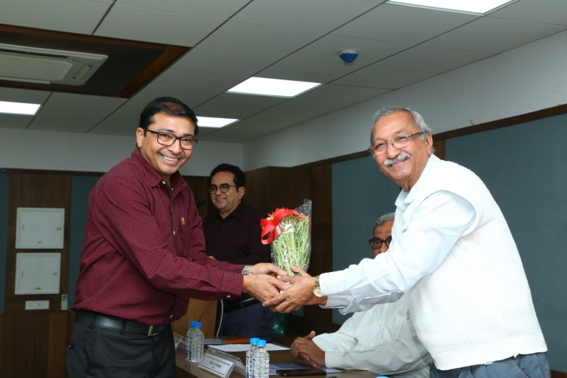
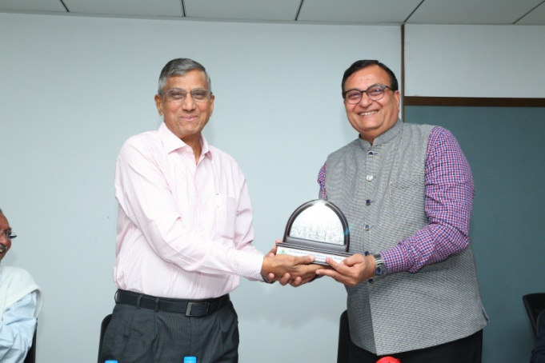
Shri Shanker Patel, President ,GESCSL presenting memento to Shri Bhupendra Patel, Regional Chairman, Chemexcil
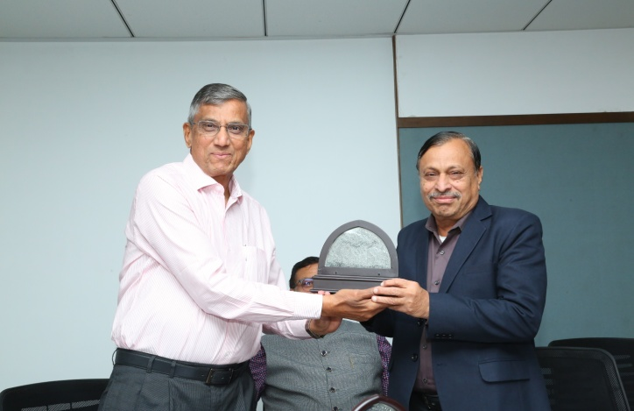
Shri Shanker Patel, President, GESCSL presenting memento to Shri Yogesh Parikh, President, GDMA

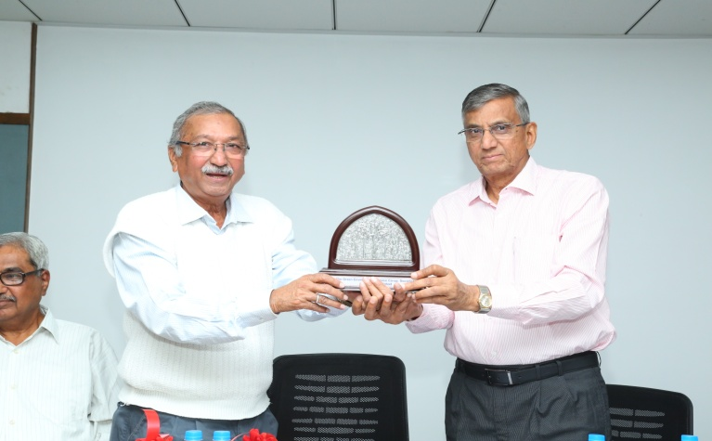
Shri Shanker Patel, President, GESCSL presenting memento to Shri S.T. Desai Gujarat Safety Council
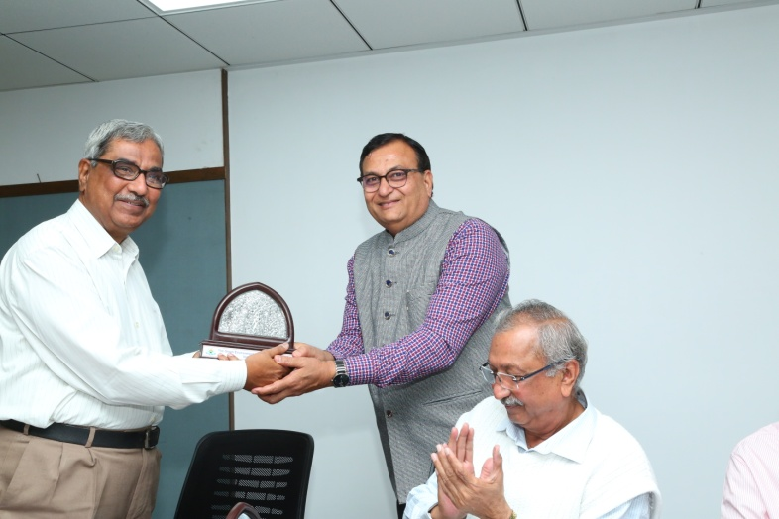
Shri Bhupendra Patel, Regional Chairman, Chemexcil presenting memento to the faculty Shri Anil Trivedi

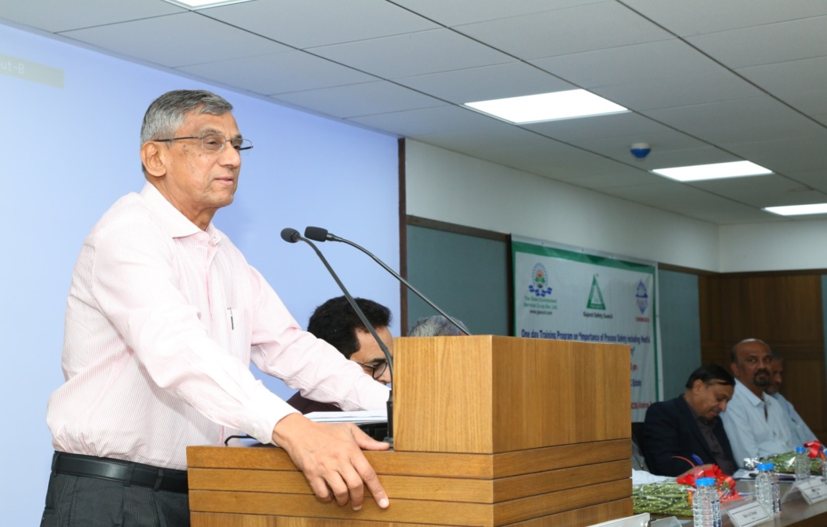
Shri Shanker Patel, Chairman, The Green Environment Services Co-Operative Society Limited delivering his welcoming speech

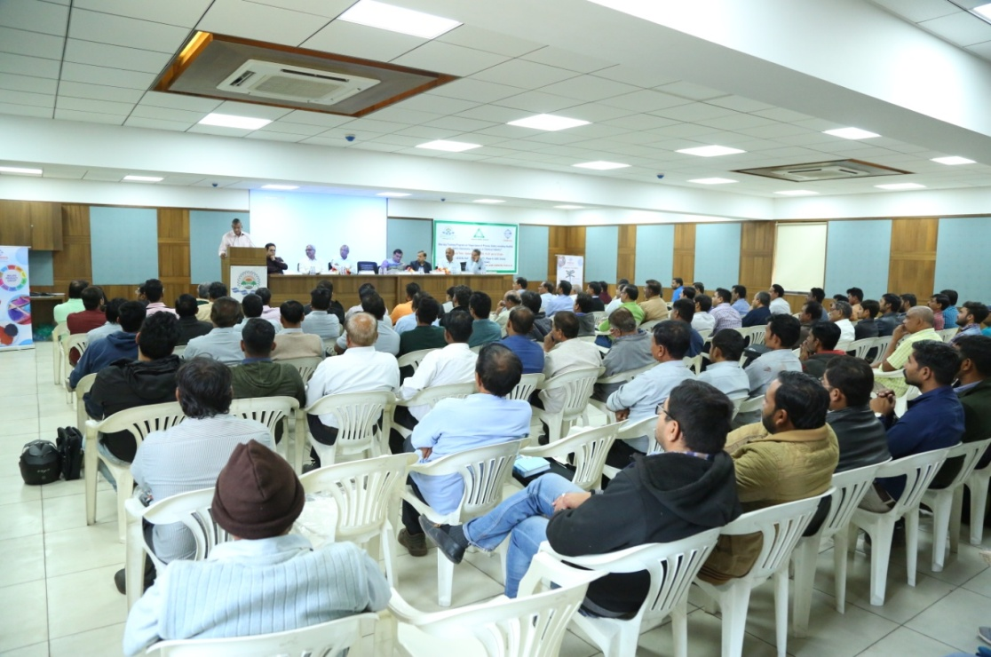

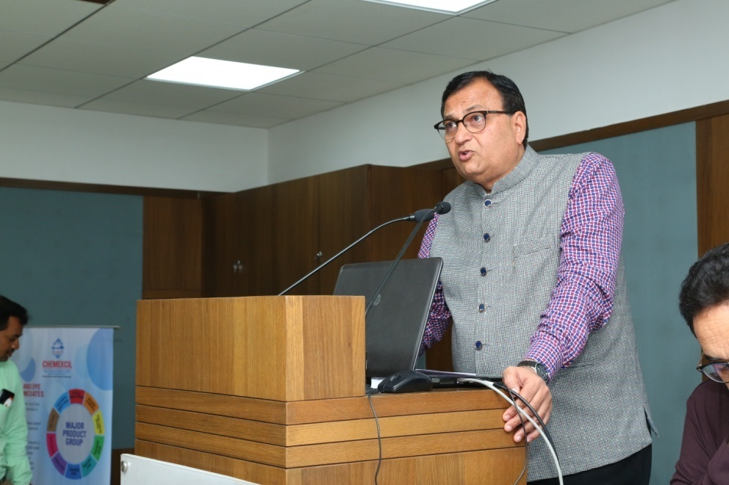

Shri Bhupendra Patel, Regional Chairman, Western Region, Chemexcil addressing the participants from Industry

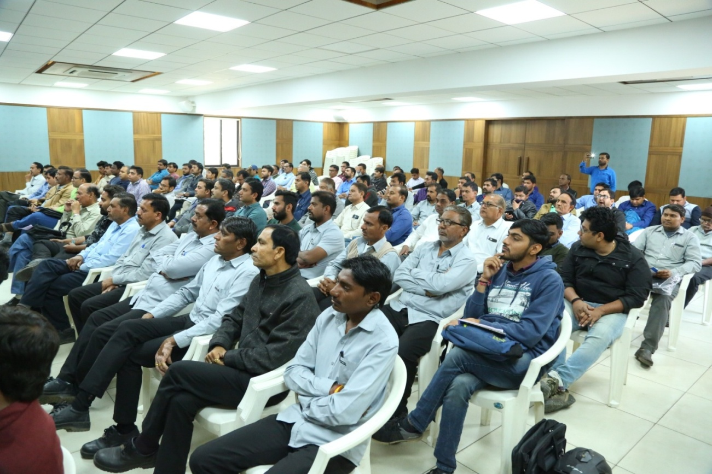

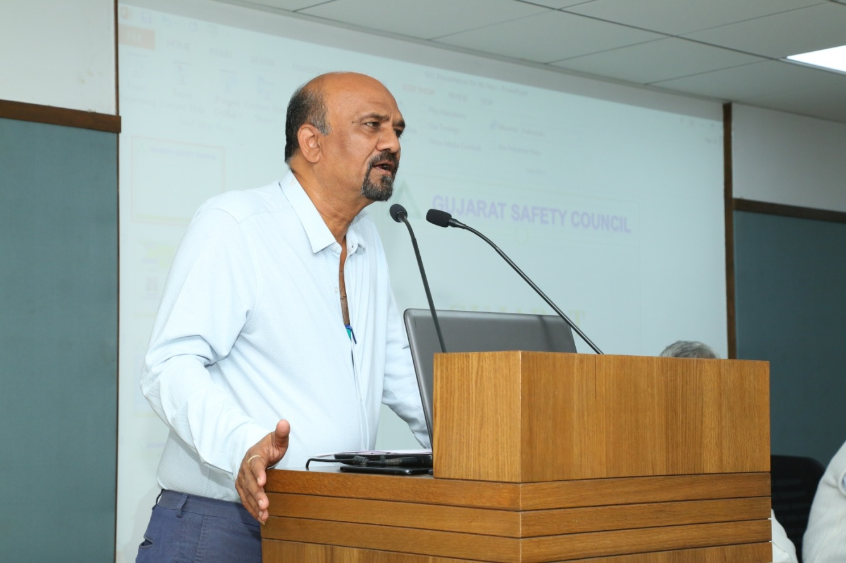
Mr. C C Vora, Deputy Director Industrial Safety & Health, Government of Gujarat
(DISH) sharing data and his view on Industrial Safety

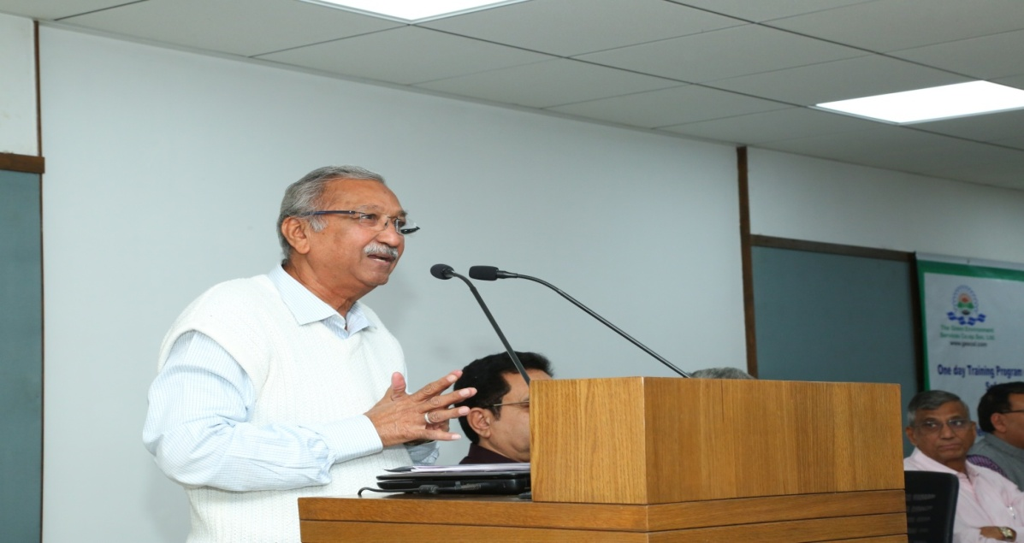
Shri S.T. Desai from Gujarat Safety Council

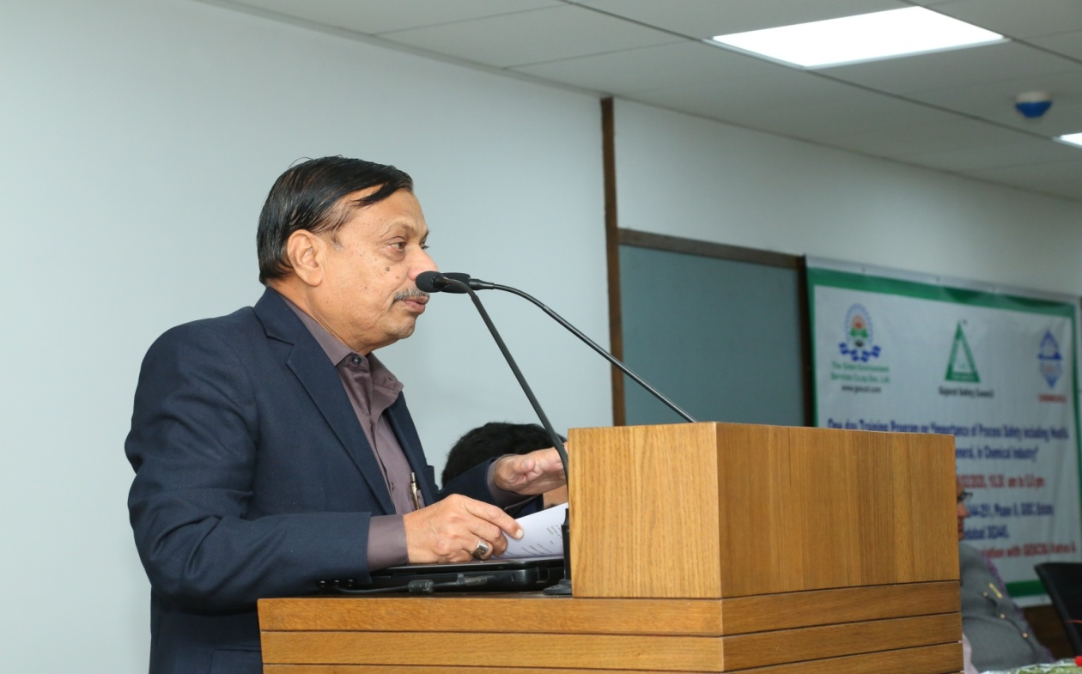
Vote of Thanks extended by Shri Yogesh Desai, President. The Gujarat Dyestuff Manufacturers’ Association (GDMA)

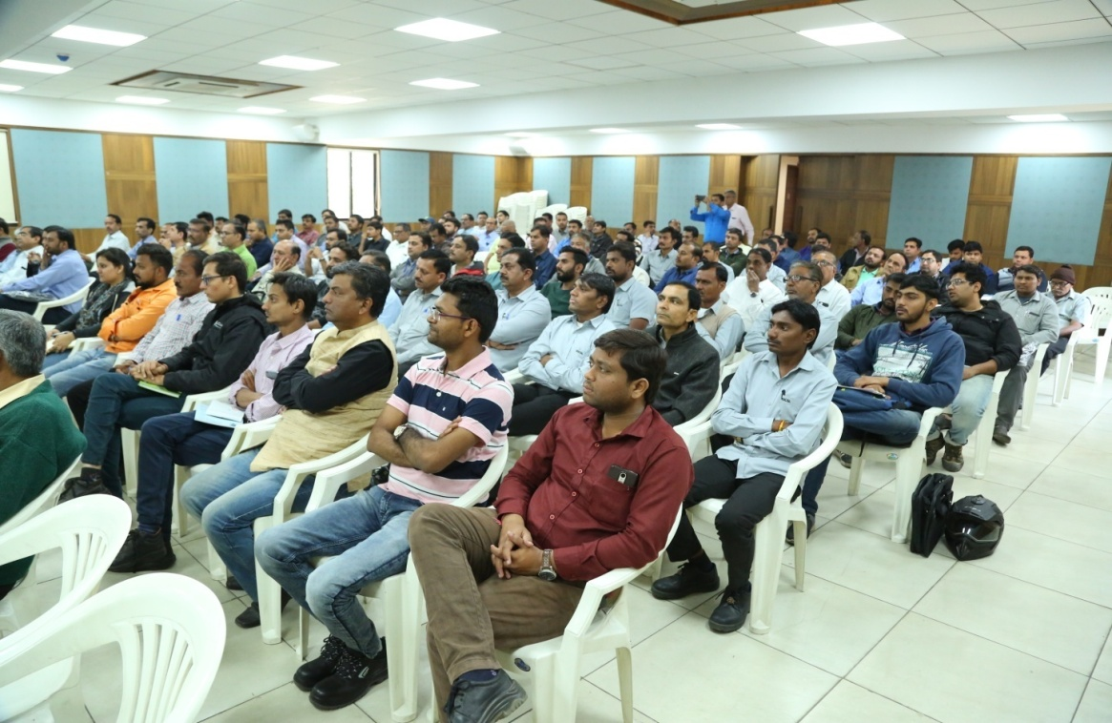
Safety Representatives from Industry

Shri A.N. Trivedi, safety Expert giving training to safety representatives
on Process Safety including Health & Safety Awareness,

