ANNEXURE - I
BRIEF REPORT

Buyer Seller Meet

10th To 16th January, 2023

Taiwan, Korea and Japan

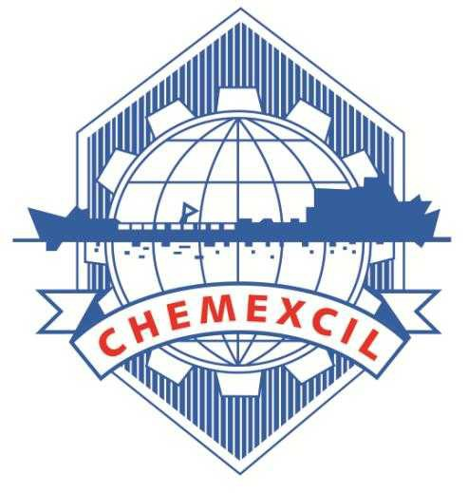

CHEMEXCIL
Basic Chemicals, Cosmetics & Dyes Export Promotion Council
(Set-up by Ministry of Commerce & Industry, Government of India)
Jhansi Castle, 4th Floor, 7- Cooperage Road, Mumbai – 400 001, INDIA
Tel: +91-22-22021288, 22021330, 22825861, 22020911, Fax: +91-22-22026684
Email: info@chemexcil.in Website: https://chemexcil.in Twitter: @chemexcil

HIGHLIGHTS

As an export promotion activity for the year 2022-2023 Chemexcil has participated in Buyer Seller Meet 10th To 16th Jan , 2023 Taiwan, Korea and Japan. This event was recommended to DOC under the MAI Scheme of the Department of Commerce, Government of India.

Chemexcil has already received the confirmation from respective Indian Missions in Taiwan, Korea and Japan and accordingly initial meetings were conducted with the concern person in Indian Missions. This event is already recommended to DOC under MAI scheme of Department of Commerce, Government of India. The Ministry of Commerce has approved the said project & Industry under MAI scheme vide letter no. F. NO. K-11020/431/2021-E&MDA dated 7th June 2022 (Minutes of Meetings of Sub-Committee of MAI to consider proposals for MAI assistance for the activities to be undertaken by EPC's/ Trade Bodies during the FY 2022-23) for 25-exhibitors approving the MAI grant of INR 37.5 Lacs.

Taiwan is a good market especially for Inorganic, Organic, and Agro chemicals. In value terms, the total export performance of the items covered under the purview of CHEMEXCIL to Taiwan for the year 2021-22 was USD 289.33 million registering growth of 54 % on previous year of exports to Taiwan out of which, exports of Dyes & Dye Intermediate, accounted for USD 45.25, Basic Inorganic, Organic Chemicals including Agrochemicals is USD 231.17 million, Cosmetics, Soaps, Toiletries and Essential oils is USD 7.06 million

Korea is a good market especially for Inorganic, Organic, and Agro chemicals. In value terms, the total export performance of the items covered under the purview of CHEMEXCIL to Korea for the year 2021-22 was USD 460.09 million registering growth of 45 % on previous year of exports to Korea out of which, exports of Dyes & Dye Intermediate, accounted for USD 90 million, Basic Inorganic, Organic Chemicals including Agrochemicals is USD 323 million, Cosmetics, Soaps, Toiletries and Essential oils is USD 27 million

Japan is also a good market especially for Inorganic, Organic, and Agro chemicals. In value terms, the total export performance of the items covered under the purview of CHEMEXCIL to Japan for the year 2021-22 was USD 680 million registering growth of 37 % on previous year of exports to Japan out of which, exports of Dyes & Dye Intermediate, accounted for USD 106 million, Basic Inorganic, Organic Chemicals including Agrochemicals is USD 494 million, Cosmetics, Soaps, Toiletries and Essential oils is USD 33 million

Taiwan, Korea and Japan is an important market especially for Dyes & Dye Intermediates, Inorganics, Organics & Agro Chemicals, Essential Oils and Cosmetics sector. The main objectives to organize Indian Pavilion Meet were:-
- Building a vibrant platform for promoting exports to Bangladesh by establishing good business relations with enterprises and commercial organizations.
- Exploring the possibility of expanding two-way trade.
- Exploring the possibility of collaboration in the Bangladesh region.

Following a long wait of three years, Taiwan, Korea and Japan has continued to be the perfect platform for the businesses to connect with the International Fine & Specialty Chemical market.

The Inauguration Ceremony was organized on 10th January, 2023 at 10.00 am. In Taiwan (Taiwan Time). The Buyer Seller Meet was inaugurated by Shri Gourangalal Das, Director General, ITA Taiwan. along with Mr. S.G. Mokashi, Chairman, CHEMEXCIL and Mr. Prafulla Walhe, Deputy Director, CHEMEXCIL and Industry Association.

The Inauguration Ceremony was organized on 12th January, 2023 at 10.00 am. In Seoul (Korea Time). The Buyer Seller Meet was inaugurated by Shri Amit Kumar, Ambassador of India, Seoul. Along with Mr. S.G. Mokashi, Chairman, CHEMEXCIL and Mr. Prafulla Walhe, Deputy Director, CHEMEXCIL.

The Inauguration Ceremony was organized on 16th January, 2023 at 10.00 am. In Tokyo (Japan Time). The Buyer Seller Meet was inaugurated by Shri Sibi George, Ambassador of India, Tokyo. Along with Mr. S.G. Mokashi, Chairman, CHEMEXCIL and Mr. Prafulla Walhe, Deputy Director, CHEMEXCIL.

In the Total 27 member-exporters from CHEMEXCIL participated in this Buyer Seller Meet.

GLIMPSES OF

CHEMEXCIL’S PARTICIPATION IN

Buyer Seller Meet

10th To 16th January, 2023

Taiwan, Korea and Japan

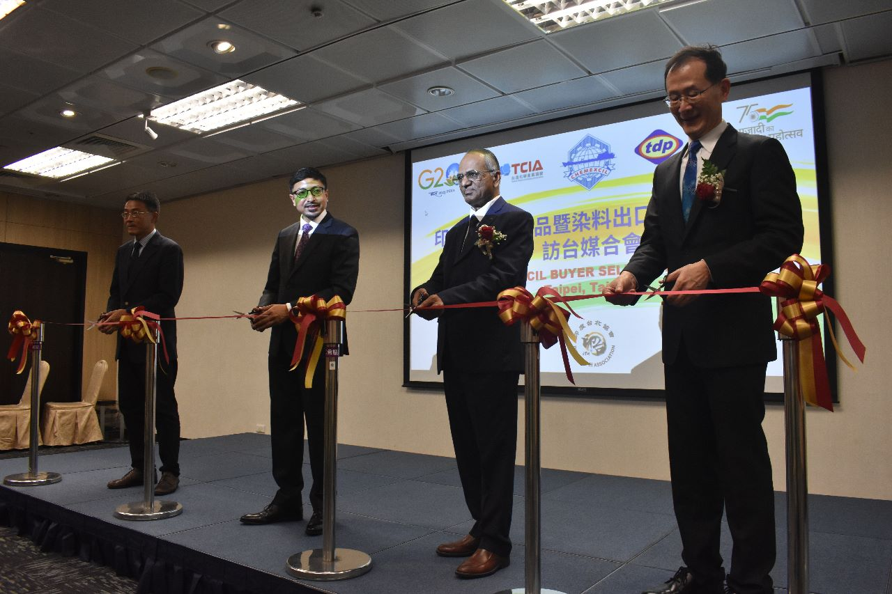

Taiwan Inauguration along Shri Gourangalal Das, Director General, ITA Taiwan along with Mr. S.G. Mokashi Chairman, CHEMEXCIL and Industry Association

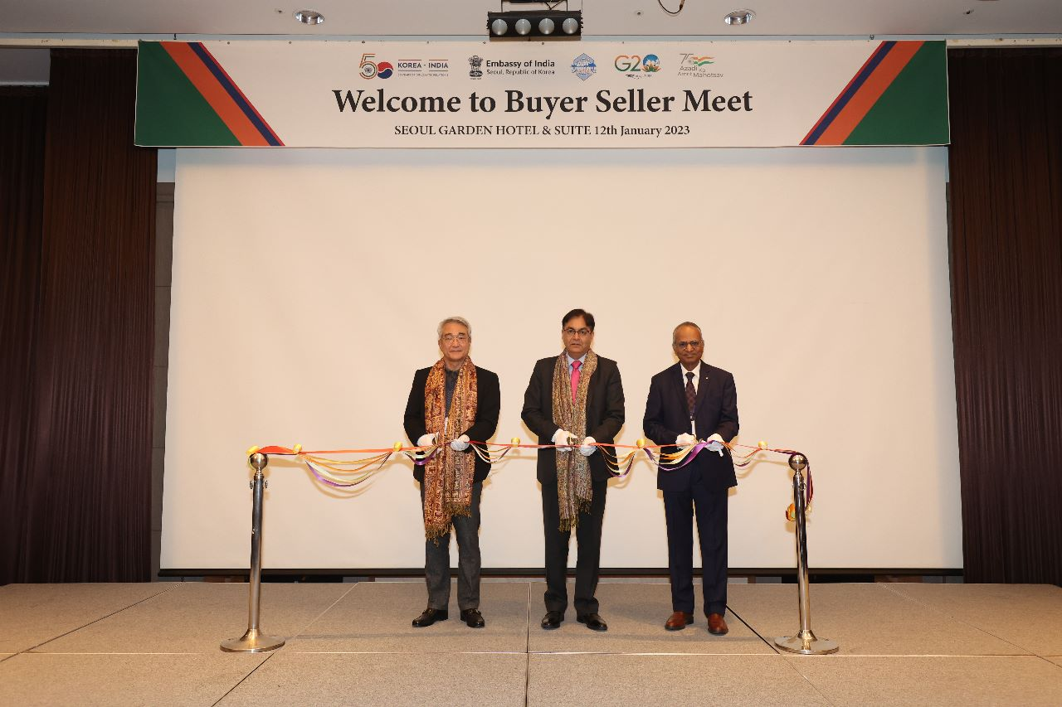

Korea Inauguration along Shri Amit Kumar, Ambassador of India, Seoul. Along with Mr. S.G. Mokashi, Chairman, CHEMEXCIL and Industry Association
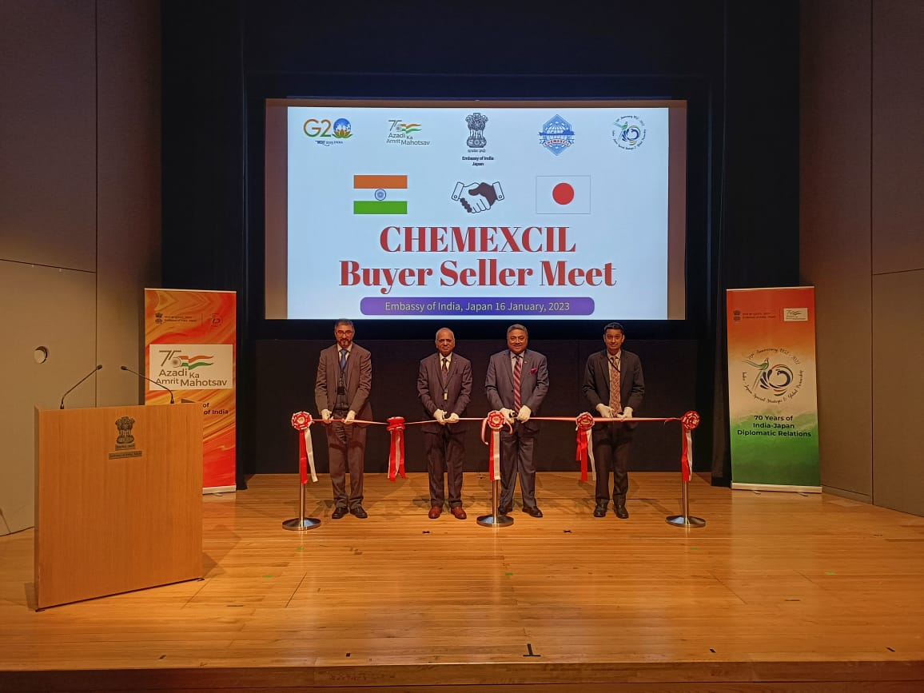

Tokyo Inauguration along Sibi George, Ambassador of India, Tokyo. Along with Mr. S.G. Mokashi, Chairman, CHEMEXCIL and Industry Association

