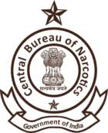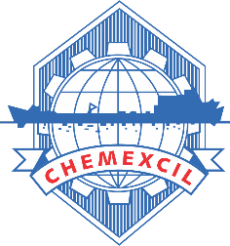

WORKSHOP TO BE HELD ON

29th May 2025 at Torrent Seminar Hall

Vatva Industries Association, Centre Of Excellence Building

Plot 511, Phase 4, Mahemdabad Highway,GIDC Vatva Ahmedabad.

|  |  |
| --- | --- |
| ***TIMINGS*** | ***EVENTS*** |
| 10.30 am - 11.00 am | Registration and Breakfast |
| 11.00 am - 11.20 am | Welcome Remark and Introduction of theme of the workshop by Dr. Satish Wagh Chairman CHEMEXCIL |
| 11.20 am -11.30 am | Welcome Remark by Shri Brijendra Chowdhary Dy. Narcotics Commissioner (HQRS.) |
| 11.30 am - 11.40 am | Statement of Purpose by Shri Dinesh Bouddh, Narcotics Commissioner of India. |
| 11.40 am -12.00 pm | Presentation on Online System of CBN & return of ISSL Chemicals |
| 12.00 pm -12.45 pm | Presentation on Voluntary Code of Conduct by CBN |
| ***LUNCH BREAK 12.45 pm - 14.00 pm*** | |
| 14.00pm -15.00 pm | Presentations on Annual RODTEP Returns filing |
| ***TEA BREAK 15.00 pm -15.30 pm*** | |
| 15.00 pm- 15.30 pm | Panel Discussions   * Narcotics Commissioner of India * Deputy Narcotics Commissioner, Rajasthan * Deputy Narcotics Commissioner, Madhya Pradesh * Two representatives of Industries |
| 15.30 pm - 15.40 pm | Vote of thanks by Shri Raghuveer Kini Director General CHEMEXCIL |